Name: ­­­­­­­­_________________________________

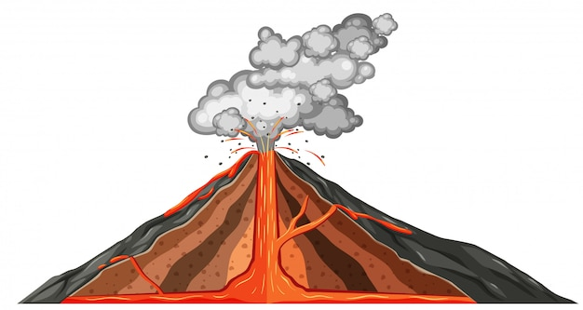

Date: _________________________________

**MOUNTAIN OF FIRE**

Fill in the blanks.

A volcano is formed when a _________________ in the earth's crust causes molten rock to erupt onto the earth's surface, forming a ________________________.

There are __________ active volcanoes on our planet and ______% of eruptions take place in the ___________. Volcanoes allow the earth to release the ___________ and ________________ trapped under its crust.

Vulcan is an example of a myth and _____________ around volcanoes.

The eruption of __________________________ in 1815 is considered the most destructive volcanic event in history. __________________________ is the largest volcano on earth. The _________________ volcano is considered the most active volcano in the world. ____________________________ , located on ______________is the largest volcano in our solar system.

Deep inside the earth, temperature and ___________________ are so high that rocks forming the earth's _____________ melt, forming ___________. A volcano erupts when magma _____________ and erupts through a crack in the earth's crust. Magma is called __________ once it's on the surface.

_______________________________________ are the founders of volcanology.

A __________________________ is a machine that measures vibrations. Spectrometers measure the _________________ emitted by volcanoes and volcanologists now install them on _______________.

Answer Key

A volcano is formed when a **fracture** in the earth's crust causes molten rock to erupt onto the earth's surface, forming a **crater.**

There are **1500** active volcanoes on our planet and **75**% of eruptions take place in the **ocean.** Volcanoes allow the earth to release the **heat** and **pressure** trapped under its crust.

Vulcan is an example of a myth and **legend** around volcanoes.

The eruption of **Mount Tambora** in 1815 is considered the most destructive volcanic event in history. **Mauna Loa** is the largest volcano on earth. The **Kilauea** volcano is considered the most active volcano in the world. **Olympus Mons**, located on **Mars** is the largest volcano in our solar system.

Deep inside the earth, temperature and **pressure** are so high that rocks forming the earth's **mantle** melt, forming **magma.** A volcano erupts when magma **rises** and erupts through a crack in the earth's crust. Magma is called **lava** once it's on the surface.

**Maurice and Katia Krafft** are the founders of volcanology.

A **seismograph** a machine that measures vibrations. Spectrometers measure the **gases** emitted by volcanoes and volcanologists now install them on **drones.**