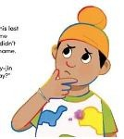SAAJIN’S WORDSEARCH
Name:

Help find the hidden words!
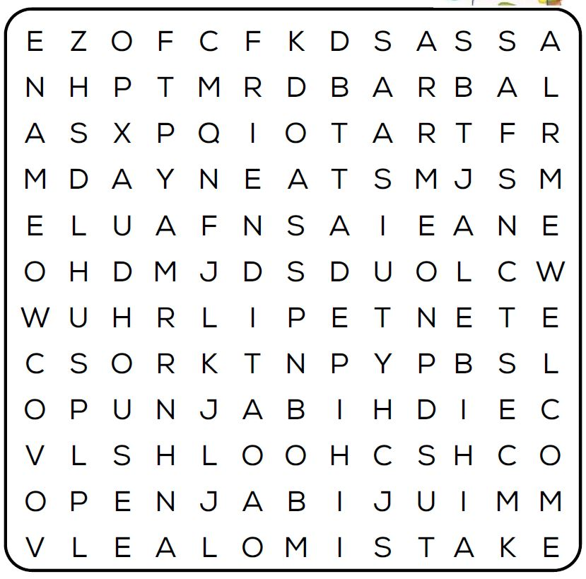

SAAJIN FRIEND NAME
JALEBI PUNJABI SCHOOL
CLOUDS MISTAKE STARS
WELCOME ROTI HOUSE

SAAJIN’S WORDSEARCH

_{Name:} ANSWER KEY
Help find the hidden words!

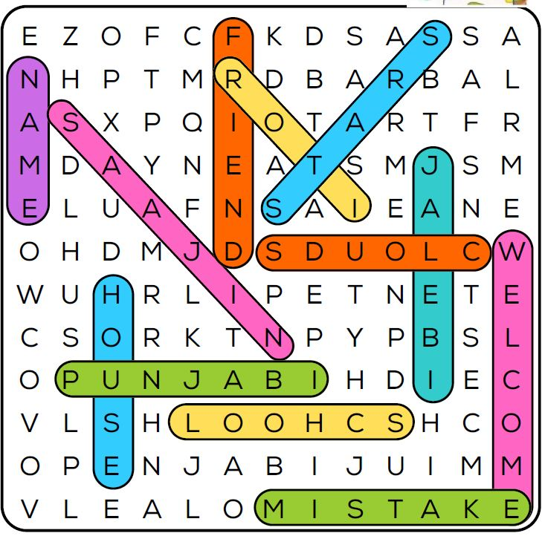

SAAJIN FRIEND NAME
JALEBI PUNJABI SCHOOL
CLOUDS MISTAKE STARS
WELCOME ROTI HOUSE

