NAME ART!
Name:

- 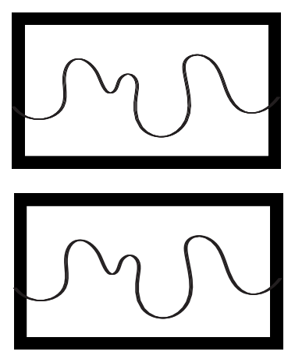Make a squiggly line to divide the box below in half horizontally.
S
Si
A
A
j
g

- 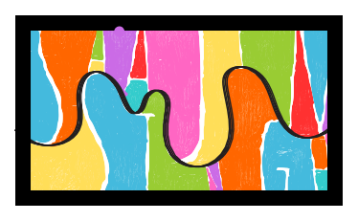Write your first and last name on either side of the line, making sure each letter touches the top and bottom.
S
Si
A
A
j
g

- Colour each section!

