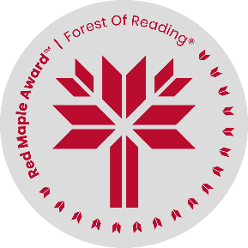
Name : ___________________

A Bucket of Stars by Suri Rosen
Discussion Questions

- In Bucket of Stars, Astronomy is the one thing that Noah truly loves.
Make a list below of the things you really like. Which one is your favourite and why?

________________________________________________________________________

________________________________________________________________________

________________________________________________________________________

________________________________________________________________________

________________________________________________________________________

________________________________________________________________________

________________________________________________________________________

________________________________________________________________________

- The novel includes the real-life blackout on August 14, 2003. See the satellite images in the link below:
https://earthobservatory.nasa.gov/images/3719/blackout-leaves-american-cities-in-the-dark
What would you and your family do if all the electricity went out in your house tonight?

________________________________________________________________________

________________________________________________________________________

________________________________________________________________________

________________________________________________________________________

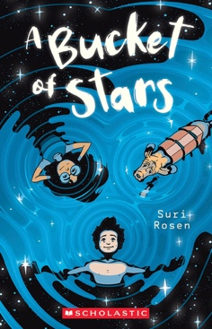
________________________________________________________________________

________________________________________________________________________

________________________________________________________________________

________________________________________________________________________
Name : ___________________

- Noah and Tara make a movie to try and protect a historical building, the Graham estate. Do you think historical buildings like this should be saved or should they be torn down to make way for new places to live? Fill in the chart below:

Should historical buildings be saved?
Pros – Yes! | Cons - No!
Keeping them helps us to understand the people who came before us and connects us to our towns and cities. | These big buildings take up too much space. 50 new smaller homes could be built in their place.

- Noah risks his life to go back for his dad’s Celestron binoculars. Is there an item you or your family owns that you would risk your life for? If not, what would be the item that you would go back for? Write your answer in the space below.

________________________________________________________________________

________________________________________________________________________

________________________________________________________________________

________________________________________________________________________

________________________________________________________________________
________________________________________________________________________

________________________________________________________________________

________________________________________________________________________

