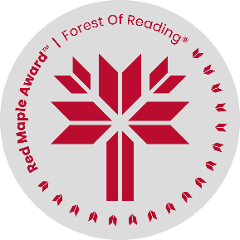
Name : ___________________

A Bucket of Stars by Suri Rosen
Inquiry Activities – Choose 1 or more of the inquiry questions below.

- A bucket of stars is full of astronomy information and facts. Would you like to know more about astronomy or space? Browse these astronomy websites below and summarize what you find for your classmates.

Website #1 - https://hubblesite.org/ Hubble Space Telescope

Website #2 - https://apod.nasa.gov/apod/astropix.html Astronomy Picture of the Day

Website #3 - https://www.planetary.org/ The Planetary Society

Website #4 – What site would you recommend?

- In the novel, Noah worries that the building of a subdivision will lighten the night sky. Research “light pollution” and share your findings with your class in a short talk, or digitally with a PowerPoint or Google Slide presentation.
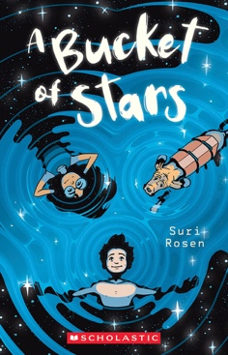
Consider the following articles to help you get started:

https://www.britannica.com/science/light-pollution

https://education.nationalgeographic.org/resource/light-pollution/

https://astro-canada.ca/la_pollution_lumineuse-light_pollution-eng

What else is affected when a new subdivision is built?
Read what Mr. Fontana says on p. 116 if you need a hint.

- Kyle, Noah and their dad, James are experiencing a number of losses in their lives. Their mom (James’ wife) died, they left their family home in Alberta and all their friends to live in Ontario. Noah says,

“…Dad really lost his way…He lost interest in astronomy. He lost interest in playing chess with Kyle. He lost interest in Kyle. And finally he lost interest in me too. Dad suffered from constant headaches and couldn’t tolerate any noise.”

Imagine Noah is your best friend. What advice would you give him? What resources can you find to help him and his family? Can you relate to Noah either in your own life or in the movies, tv shows or books you may know?

