Name : ___________________

A Bucket of Stars by Suri Rosen
Art Activities

- Research some of the constellations Noah talks about in the novel such as Orion, Ursa Major and Minor, and Cassiopeia. Create a work of art representing the star formations such as this painting below from https://www.nationalgeographic.com/family/article/paint-a-constellation
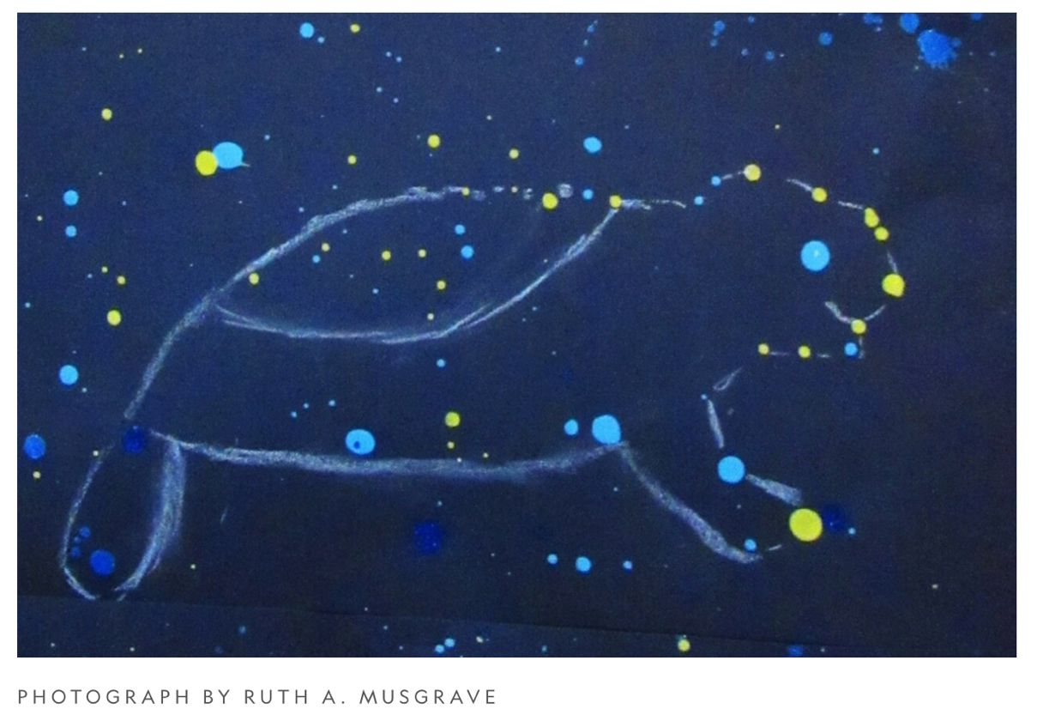
Search “Constellation Art Ideas” for more ideas.

- Imagine you are friends with Noah and Tara and they want you to come up with the next Max Newman movie. Max has been an astronomer, a bank robber, a cashier, a Doctor and a taxi driver. What adventure will you send Max on next?
Make a list below with some story ideas.
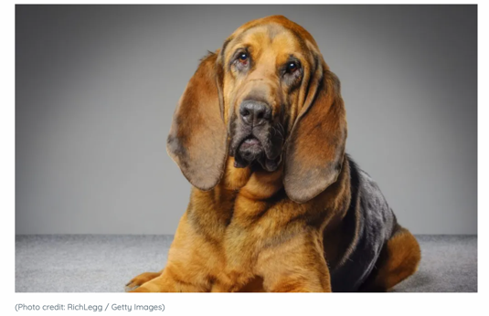
_________________________________________

_________________________________________

_________________________________________

_________________________________________

https://dogtime.com/dog-breeds/bloodhound

________________________________________________________________________
Name : ___________________

A Bucket of Stars by Suri Rosen
Art Activities

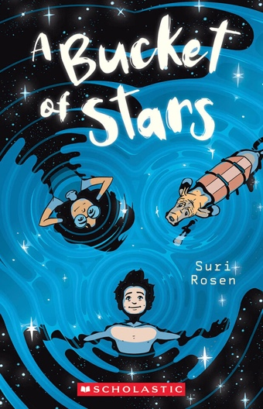
- Design a new cover for the book. Be sure to consider the font, colour scheme and characters featured.

- Film a trailer for the book using a cell phone or other device. Match the trailer’s tone with that of the book. What scenes would you include? Make a list below.

_______________________________________________________________________

_______________________________________________________________________

_______________________________________________________________________

