Name : ___________________

A Bucket of Stars by Suri Rosen
Word Search
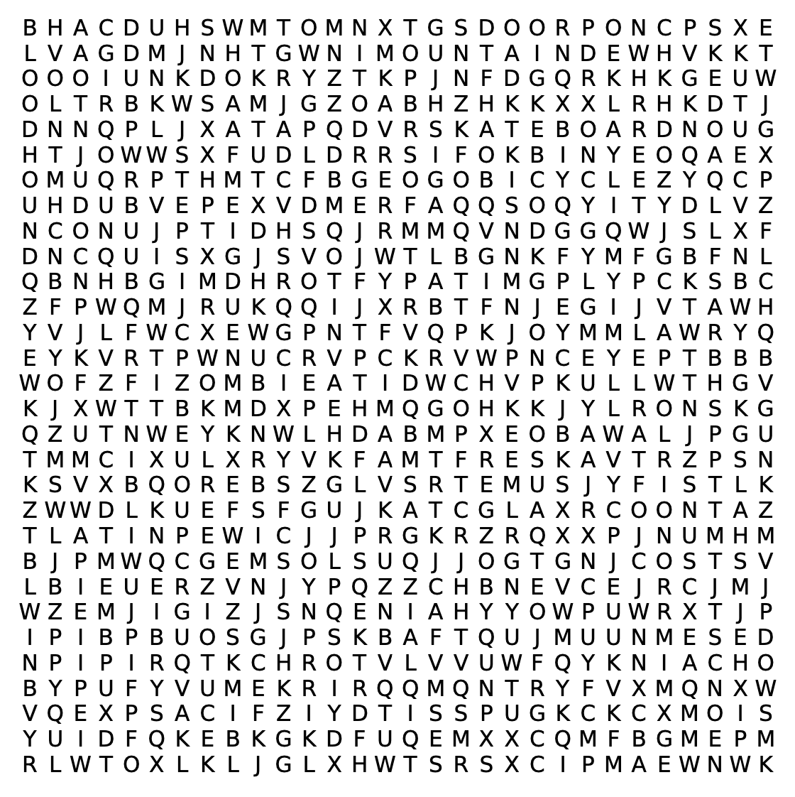

Word bank

Alberta astronomy bicycle binoculars bloodhound

chess Graham Latin MaxNewman MountainDew

Ontario Queensport skateboard telescope zombie

Name : Answer Key

A Bucket of Stars by Suri Rosen
Word Search
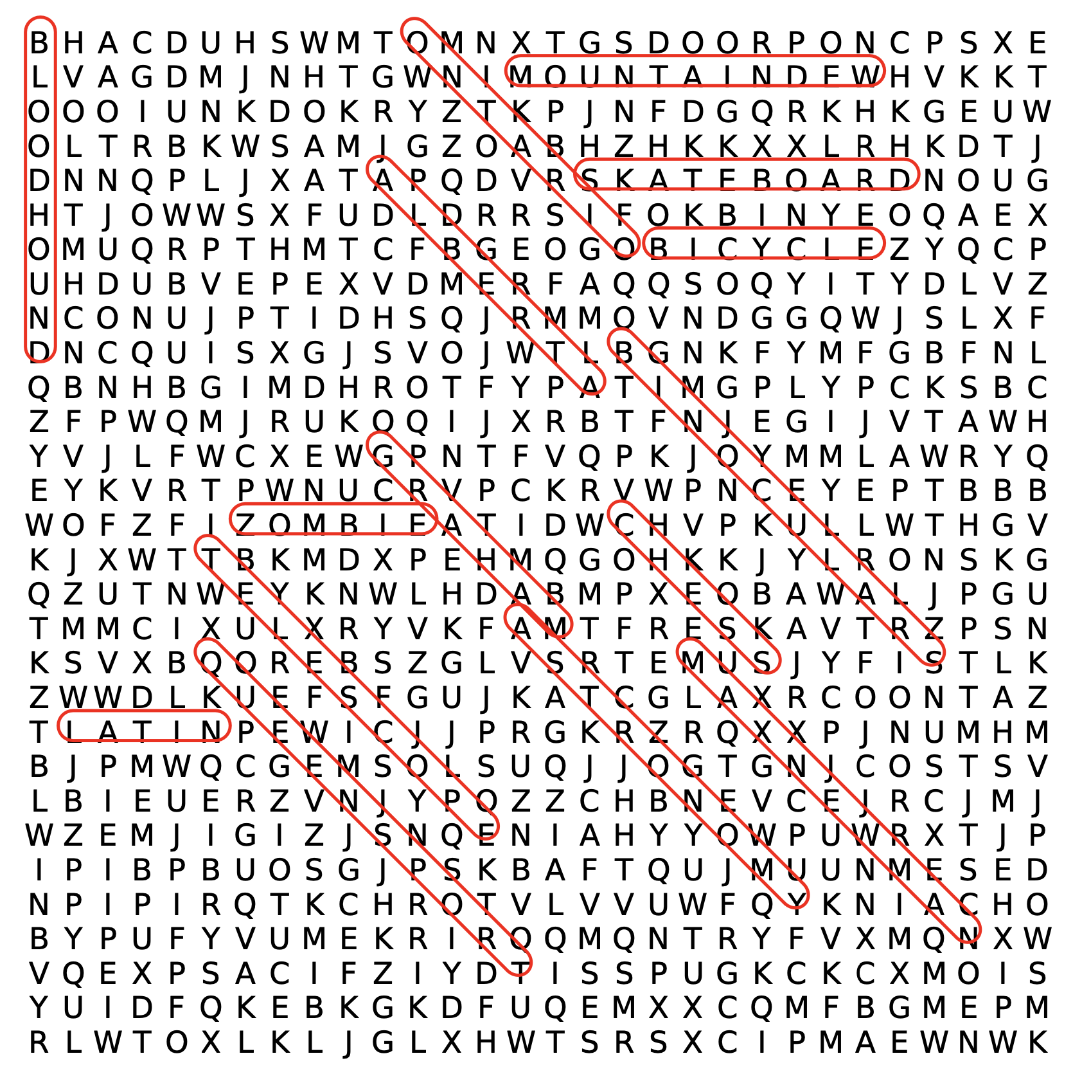

Word bank

Alberta astronomy bicycle binoculars bloodhound

chess Graham Latin MaxNewman MountainDew

Ontario Queensport skateboard telescope zombie

