Name : ___________________

The Last Saxon King by Andrew Varga

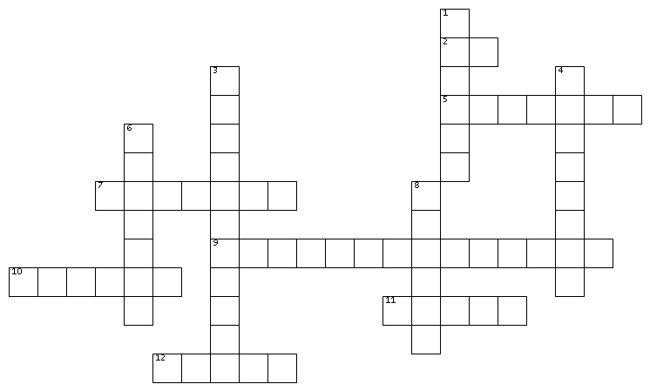

Use the clues to fill in the words above.

Words can go across or down. Letters are shared when the words intersect.

ACROSS
2. The name of the sell-sword Dan killed
5. The country Dan time travels to
7. The medieval name Dan chose for himself
9. The place of the first battle Dan leads the King to fight the Vikings
10. First name of the man who was fighting with Dan's dad
11. The priest forced Dan to drink holy ___________ .
12. Where Dan takes Sam at the end of the book.
DOWN
1. The only good thing about Sam's new home
3. Victor's day job
4. William and Harold meet near the town of _____________ .
6. The crime Dan is accused of
8. Dan chose Trial by _____________ .
Word Bank

Congressman
Dance
England
Forest
Hastings
Leofric
Ordeal
Ox
Stamford Bridge
Treason
Victor
Water

Name : Answer Key

The Last Saxon King by Andrew Varga

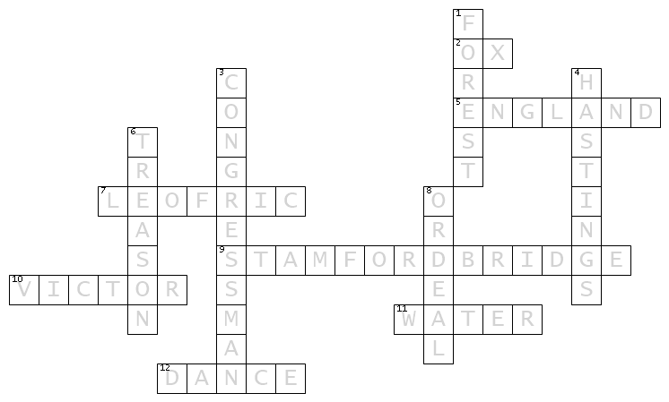
ACROSS
2. The name of the sell-sword Dan killed
5. The country Dan time travels to
7. The medieval name Dan chose for himself
9. The place of the first battle Dan leads the King to fight the Vikings
10. First name of the man who was fighting with Dan's dad
11. The priest forced Dan to drink holy ___________ .
12. Where Dan takes Sam at the end of the book.
DOWN
1. The only good thing about Sam's new home
3. Victor's day job
4. William and Harold meet near the town of _____________ .
6. The crime Dan is accused of
8. Dan chose Trail by _____________ .
Word Bank

Congressman
Dance
England
Forest
Hastings
Leofric
Ordeal
Ox
Stamford Bridge
Treason
Victor
Water

