Name : ___________________

The Last Saxon King by Andrew Varga
Art Activities

Choose 1 or more of the following Art options below :

Visual Art
- Create a tapestry of our own. Consider and explore the Bayeux Tapestry. Then, make your own either on paper or digitally that depicts a typical day in your life. Be sure to include details about your life such as your dress, your home and any “tools” you think depict life.
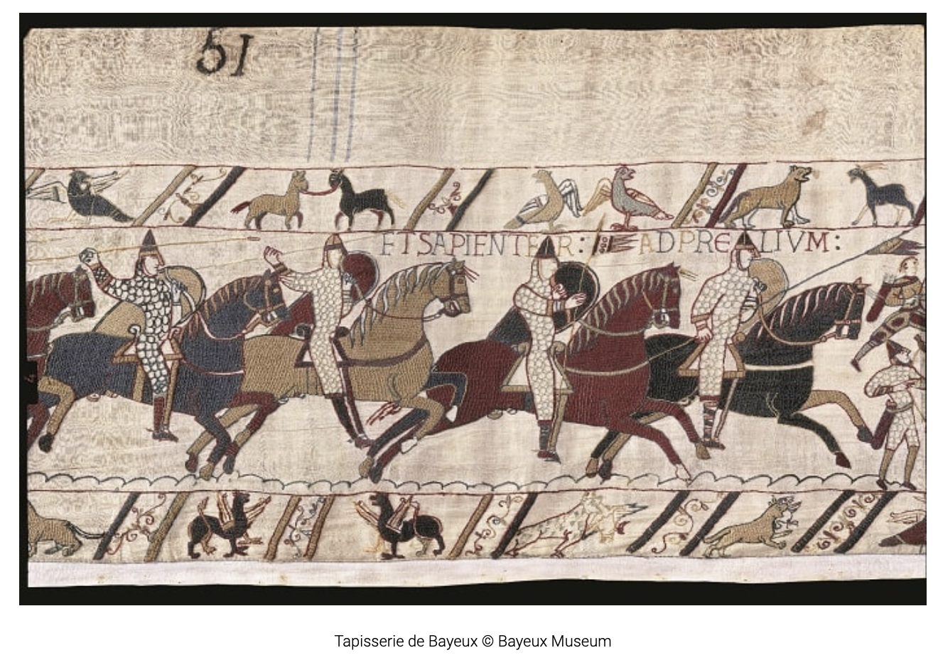
From https://www.britannica.com/topic/Bayeux-Tapestry
“The tapestry is of greater interest as a work of art. It is also important evidence for the history of the Norman Conquest, especially for Harold’s relation to William before 1066; its story of events seems straightforward and convincing,…”

You can explore the entire Tapestry online using this link :
https://www.bayeuxmuseum.com/en/the-bayeux-tapestry/discover-the-bayeux-tapestry/explore-online/

- Drama
Choose a favourite scene of your own or from the list below and create a storyboard and/or act it out with a small group of friends.

Scene 1
Dan finds his father in a fight with Victor and uses the jump device for the first time.
(pages 13-16)

Scene 2
Dan is saved from a fight by Sam and then discovers something surprising.
(pages 69-74)

Scene 3
After a battle Dan is told by Caedmon, “The king bade for all able men to clean the battlefield.” He joins the others who look for anything of value such as weapons or clothing. However, Dan finds something even worse than the rotting corpses.
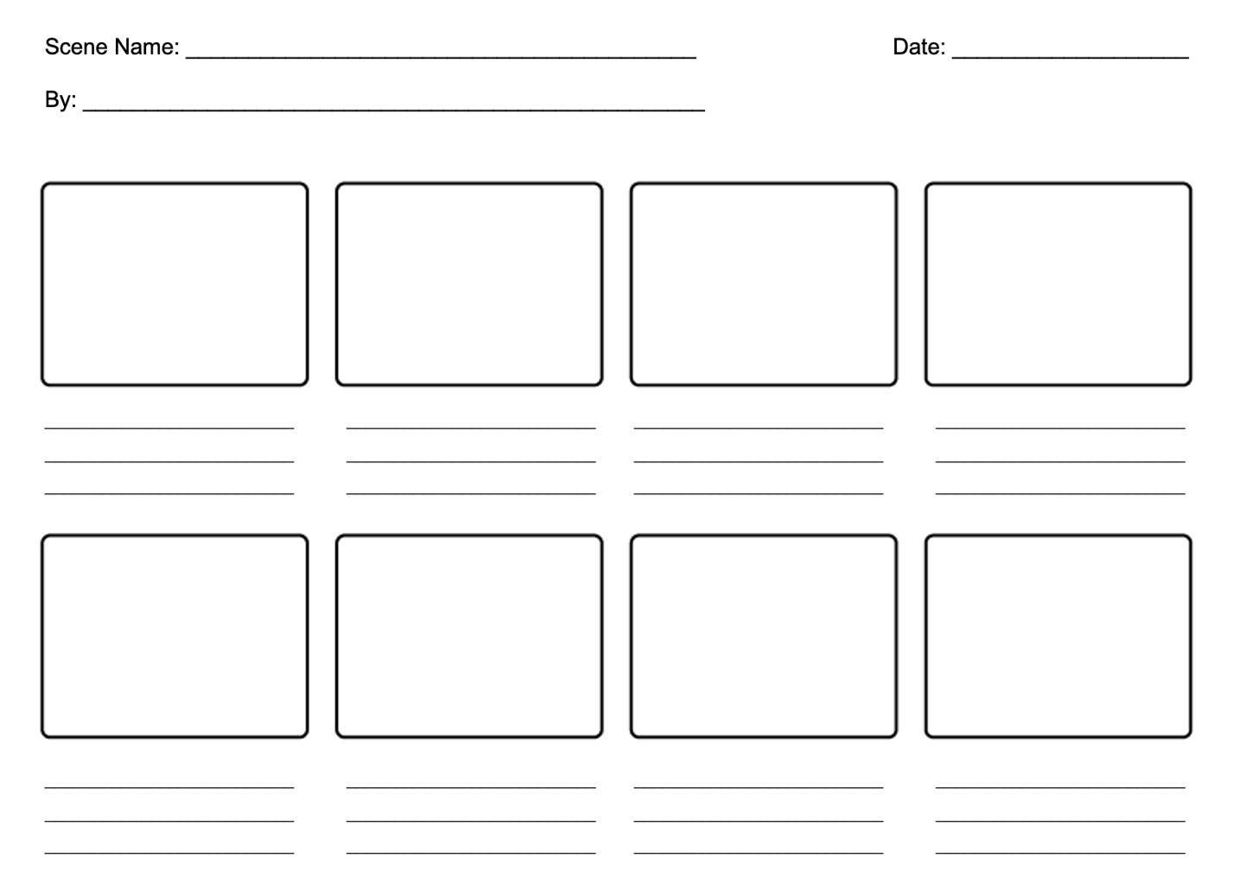
(pages 115-116)

*template adapted from educationworld
https://www.educationworld.com/tools_templates/template_strybrd_8panels.doc#google_vignette

