Name : ___________________

The Last Saxon King by Andrew Varga
Inquiry Activities

Choose 1 or more activities from the list below:

- From the book jacket, “Ever since his mother told him he was descended from Vikings, Andrew Varga has had a fascination for history. “
What is your family’s history? Ask your relatives what they know about your family and ask them to go back as far as they can. Then, research what you have discovered. Would you want to use a time jumping device like in the book to go back and live in their times? Why or why not?

- In Chapter 11, Sam says,

“Try being a woman in medieval times. There are worse
things than being stabbed. That’s why all the time jumpers are male – women get the short end of the stick throughout history – everywhere, every time.”

Evaluate the validity of her statement. Pick 1-2 historical periods and places and research what it was like for women. Can you think of or research other groups that might have had it worse than women?

- The last Saxon King was Harold Godwinson, depicted in the coin below.
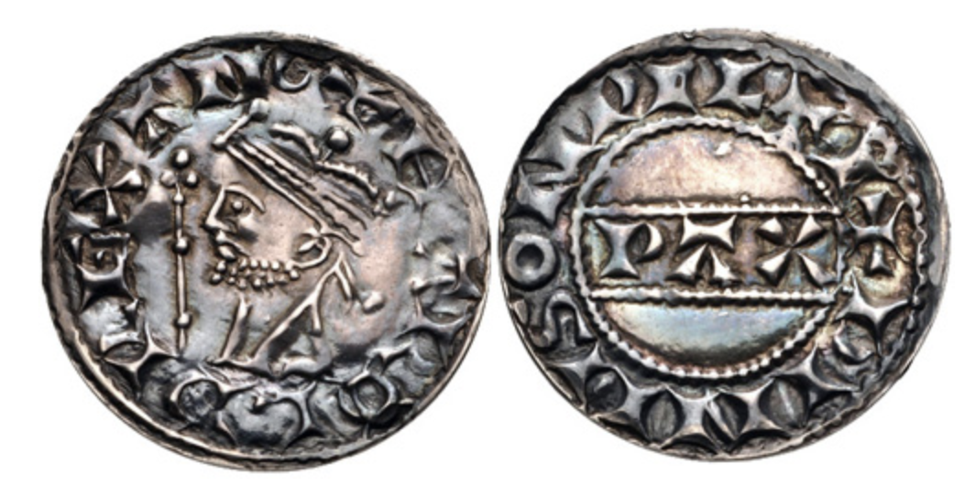
Why was he the “last Saxon King”? Who came after him? Present your findings in written or digital form (PowerPoint or Google Slides).

Picture source: https://www.cngcoins.com/Coin.aspx?CoinID=163782

