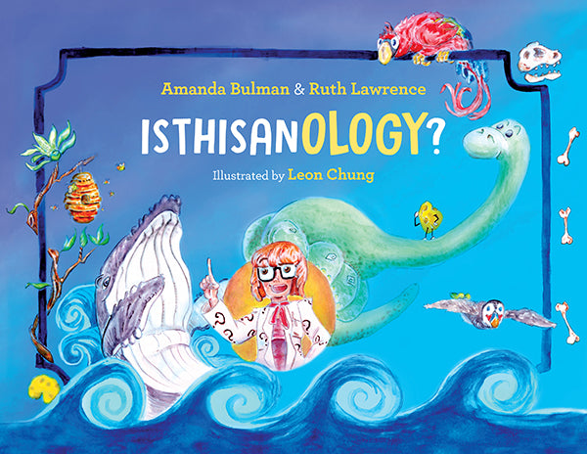

**IsThisAnOlogy  
By Amanda Bulman and Ruth Lawrence**

Pick an “ology” that was not explored in the book (e.g. zoology, biology, ecology, etc.) Research what it is, what a person that studies it does, an interesting fact about the ology, and how to become an ‘ologist’ in it.

Ology chosen:_____________________________________________________________________________

What is the ology you chose to research?

____________________________________________________________________________________________________________________________________________________________________________________________________________________________________________________

What do people that study it do?

____________________________________________________________________________________________________________________________________________________________________________________________________________________________________________________

What is an interesting fact about the ology you chose?

____________________________________________________________________________________________________________________________________________________________________________________________________________________________________________________

How does someone become an ‘ologist’ in it?­____________________________________________________________________________________________________________________________________________________________________________________________________________________________________________________

Any other interesting information to add:

_________________________________________________________________________________________________________________________________________________________________________________________________________________________________________________________________________________________________________________________________