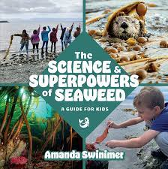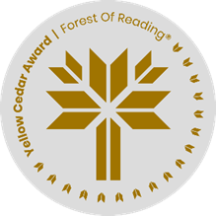

**The Science & Superpowers of Seaweed**A Guide for Kids **By Amanda Swinimer**

Seaweeds come in all shapes, sizes, and colours! Choose a type of seaweed discussed in the book, or create your own, and draw what you think it should look like based on its name. Get creative!

Seaweed’s name: _____________________________________________________