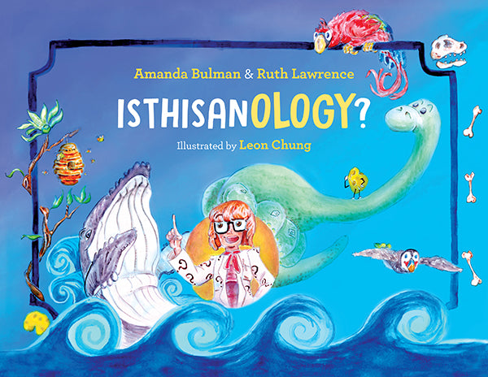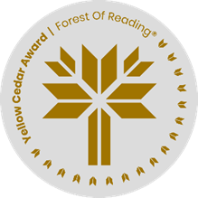

**IsThisAnOlogy  
By Amanda Bulman and Ruth Lawrence**

After reading the book, work individually or in small groups to answer and discuss the following questions.

What are ologies?

____________________________________________________________________________________________________________________________________________________________________________________________________________________________________________________

Which ology in the book did you find the most interesting? Why?

____________________________________________________________________________________________________________________________________________________________________________________________________________________________________________________

Have you undertaken any activities that would fit into any of the sciences discussed in the book? Explain.

____________________________________________________________________________________________________________________________________________________________________________________________________________________________________________________

If you could study any science, which one would you study? Why did you choose that one? ____________________________________________________________________________________________________________________________________________________________________________________________________________________________________________________

What can you do to keep learning more about the science?

______________________________________________________________________________________________________________________________________________________________________________________________________________________________________________________________________________________________________________________________________________________________________________________________________________