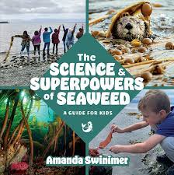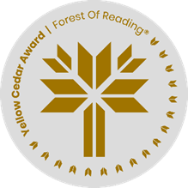

**The Science & Superpowers of Seaweed**A Guide for Kids **By Amanda Swinimer**

After reading the book, work individually or in small groups to answer and discuss the following questions.

What is seaweed?

____________________________________________________________________________________________________________________________________________________________________________________________________________________________________________________

Why is seaweed described as a superpower?

____________________________________________________________________________________________________________________________________________________________________________________________________________________________________________________

What are some of the coolest superpowers of seaweed? List at least three.

______________________________________________________________________________________________________________________________________________________________________________________________________________________________________________________________________________________________________________________________________________________________________________________________________________

What does it mean to be a sustainable seaweed harvester? Why is this important?  
­­­­­­­­­______________________________________________________________________________________________________________________________________________________________________________________________________________________________________________________________________________________________________________________________________________________________________________________________________________

What types of seaweed can you find near you? Where are the closest ones located?

_________________________________________________________________________________________________________________________________________________________________________________________________________________________________________________________________________________________________________________________________

Would you like to go harvesting seaweed? Why or why not?

_________________________________________________________________________________________________________________________________________________________________________________________________________________________________________________________________________________________________________________________________