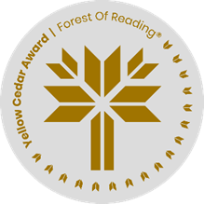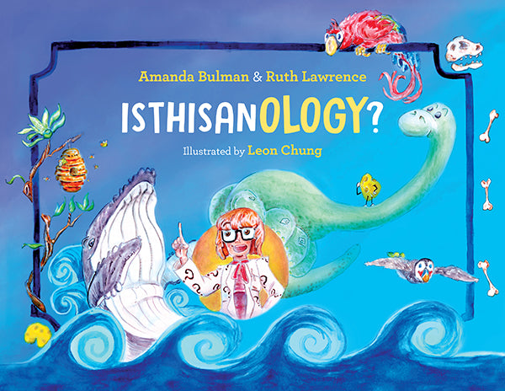

**IsThisAnOlogy  
By Amanda Bulman and Ruth Lawrence**

Extra, extra, read all about it! Choose one of the ologies from the book and write a news-worthy story that involves it. Use the space below to create the front-page story. Use your imagination to create the story. (E.g. new mineral found by a geologist, smallest dinosaur in Canada discovered by paleontologist, etc.)