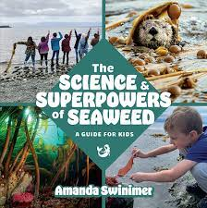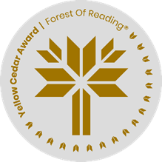

**The Science & Superpowers of Seaweed**A Guide for Kids **By Amanda Swinimer**

Seaweed Snacks! Throughout the book, the author shares food and snack ideas using seaweed in the ingredients. Using the author’s ideas, as well as researching some other ideas in the library or online, create a menu for you and your friends that showcases edible seaweeds. Yum!

Appetizer

____________________________________________________________________________________________________________________________________________________________________________________________________________________________________________________

Main Course

______________________________________________________________________________________________________________________________________________________________________________________________________________________________________________________________________________________________________________________________________________________________________________________________________________

Dessert

____________________________________________________________________________________________________________________________________________________________________________________________________________________________________________________

**never eat any seaweed unless you are sure it is a kind that is safe to eat**­­­­­­­­­