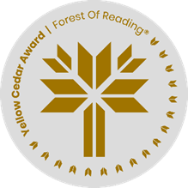

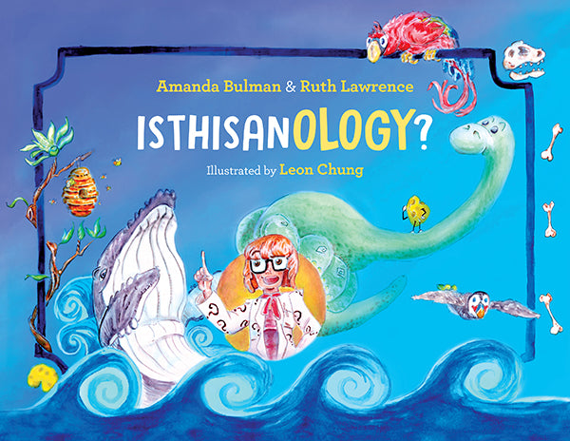 **IsThisAnOlogy?  
By Amanda Bulman & Ruth Lawrence**

|  |  |  |  |  |  |  |  |  |  |  |  |  |  |  |  |  |  |  |  |  |  |  |  |
| --- | --- | --- | --- | --- | --- | --- | --- | --- | --- | --- | --- | --- | --- | --- | --- | --- | --- | --- | --- | --- | --- | --- | --- |
| **W** | **H** | **O** | **O** | **R** | **N** | **I** | **T** | **H** | **O** | **L** | **O** | **G** | **Y** | **Z** | **L** | **K** | **D** | **J** | **F** | **R** | **X** | **K** | **S** |
| **K** | **K** | **E** | **U** | **I** | **R** | **E** | **S** | **E** | **A** | **R** | **C** | **H** | **K** | **S** | **A** | **P** | **A** | **O** | **S** | **O** | **J** | **E** | **R** |
| **U** | **E** | **P** | **W** | **E** | **O** | **S** | **F** | **G** | **Z** | **B** | **N** | **T** | **I** | **T** | **N** | **O** | **J** | **D** | **D** | **C** | **F** | **P** | **B** |
| **R** | **Y** | **A** | **L** | **G** | **K** | **Y** | **G** | **J** | **P** | **B** | **I** | **R** | **D** | **S** | **D** | **L** | **F** | **F** | **H** | **K** | **V** | **Q** | **E** |
| **B** | **P** | **L** | **X** | **U** | **T** | **N** | **W** | **O** | **Y** | **E** | **F** | **T** | **E** | **J** | **F** | **L** | **E** | **L** | **J** | **S** | **A** | **Z** | **H** |
| **E** | **F** | **E** | **A** | **B** | **M** | **W** | **A** | **R** | **F** | **Y** | **C** | **I** | **A** | **A** | **O** | **I** | **C** | **A** | **K** | **H** | **R** | **S** | **A** |
| **E** | **Q** | **O** | **J** | **D** | **C** | **A** | **S** | **E** | **O** | **L** | **O** | **G** | **Y** | **T** | **R** | **N** | **W** | **V** | **R** | **R** | **M** | **H** | **V** |
| **S** | **I** | **N** | **S** | **F** | **S** | **P** | **G** | **S** | **D** | **C** | **M** | **Q** | **N** | **W** | **M** | **A** | **Z** | **O** | **U** | **T** | **O** | **U** | **I** |
| **L** | **C** | **T** | **G** | **S** | **U** | **I** | **J** | **E** | **G** | **J** | **E** | **V** | **F** | **J** | **H** | **T** | **D** | **U** | **C** | **G** | **H** | **S** | **O** |
| **N** | **T** | **O** | **U** | **E** | **I** | **O** | **B** | **N** | **I** | **B** | **U** | **A** | **H** | **T** | **Q** | **I** | **H** | **R** | **F** | **E** | **S** | **T** | **U** |
| **D** | **S** | **L** | **L** | **Y** | **N** | **L** | **E** | **S** | **S** | **W** | **J** | **M** | **N** | **I** | **Z** | **O** | **M** | **S** | **H** | **I** | **K** | **V** | **R** |
| **E** | **X** | **O** | **R** | **H** | **C** | **O** | **S** | **E** | **J** | **C** | **H** | **E** | **E** | **S** | **E** | **N** | **I** | **T** | **G** | **S** | **W** | **B** | **I** |
| **L** | **K** | **G** | **S** | **Q** | **U** | **G** | **K** | **S** | **C** | **Z** | **W** | **O** | **P** | **L** | **K** | **H** | **G** | **E** | **O** | **L** | **O** | **G** | **Y** |
| **O** | **E** | **Y** | **T** | **O** | **M** | **Y** | **D** | **Q** | **H** | **K** | **D** | **D** | **N** | **M** | **R** | **T** | **R** | **Y** | **Q** | **F** | **S** | **Q** | **H** |
| **M** | **T** | **J** | **H** | **E** | **V** | **I** | **D** | **E** | **N** | **C** | **E** | **I** | **Q** | **E** | **C** | **E** | **A** | **H** | **Z** | **N** | **B** | **I** | **M** |
| **F** | **I** | **W** | **D** | **F** | **A** | **Q** | **F** | **R** | **A** | **O** | **H** | **E** | **L** | **R** | **Y** | **N** | **T** | **S** | **L** | **Z** | **Q** | **T** | **W** |
| **A** | **U** | **F** | **I** | **E** | **L** | **D** | **W** | **O** | **R** | **K** | **K** | **V** | **A** | **D** | **U** | **M** | **I** | **N** | **E** | **R** | **A** | **L** | **A** |
| **Z** | **J** | **M** | **C** | **H** | **I** | **U** | **I** | **A** | **L** | **P** | **E** | **J** | **H** | **H** | **W** | **G** | **O** | **B** | **F** | **I** | **C** | **G** | **D** |
| **G** | **S** | **H** | **A** | **S** | **C** | **P** | **Z** | **X** | **T** | **R** | **C** | **Y** | **R** | **C** | **F** | **K** | **N** | **X** | **A** | **D** | **V** | **J** | **B** |

ORNITHOLOGY PLUMAGE ROCKS CASEOLOGY  
 MIGRATION OCEANS GEOLOGY HABITAT  
 BEES APIOLOGY CHEESE POLLINATION  
 PALEONTOLOGY EVIDENCE HONEY BIRDS  
 FLAVOURS EARTH RESEARCH SENSES  
 FOSSILS BEHAVIOUR MINERAL FIELDWORK  
 LANDFORM