Name: ­­­­­­­­_________________________________

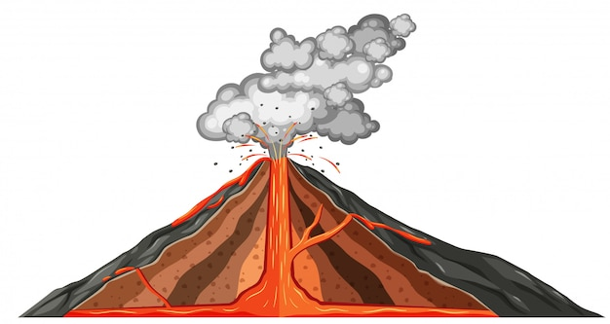

Date: _________________________________

**THE RAVEN MOTHER**

BY HETXW'MS GYETXW (BRETT D. HUSON) ILLUSTRATED BY NATASHA DONOVAN

1. In many Indigenous cultures, animals have special importance. Do some research and list some animals that are revered (highly respected) by Indigenous Peoples. (Example: "The Seven Sacred Teachings")

______________________________________________________________________________________

______________________________________________________________________________________

______________________________________________________________________________________

______________________________________________________________________________________

Source(s): ______________________________________________________________________________________

______________________________________________________________________________________

2. Choose one animal listed above. Why do some Indigenous Peoples revere this animal? (What are the teachings about this animal?)

______________________________________________________________________________________

______________________________________________________________________________________

______________________________________________________________________________________

______________________________________________________________________________________

Source(s):

______________________________________________________________________________________

______________________________________________________________________________________

3. Choose an animal listed in question 1 and provide some key information about it.

Animal: ____________________________________________________

Appearance: _______________________________________________________________________________________

_______________________________________________________________________________________

_______________________________________________________________________________________

_______________________________________________________________________________________

Habitat:

_______________________________________________________________________________________

_______________________________________________________________________________________

_______________________________________________________________________________________

_______________________________________________________________________________________

Diet:

_______________________________________________________________________________________

_______________________________________________________________________________________

_______________________________________________________________________________________

_______________________________________________________________________________________

Life Cycle:

_______________________________________________________________________________________

_______________________________________________________________________________________

_______________________________________________________________________________________

_______________________________________________________________________________________

Predators:

_______________________________________________________________________________________

_______________________________________________________________________________________

_______________________________________________________________________________________

_______________________________________________________________________________________

Two Interesting Facts:

1. _______________________________________________________________________________________

_______________________________________________________________________________________

2. _______________________________________________________________________________________

_______________________________________________________________________________________

Source(s):

_______________________________________________________________________________________