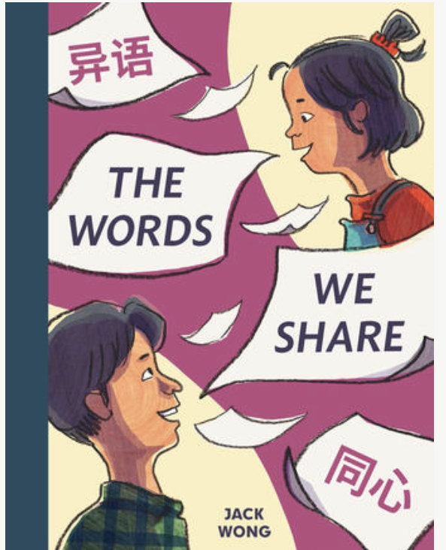
Name: ___________________________
Date: ____________________________

The Words
We Share

Written and Illustrated by Jack Wong

Art Activity
Angie likes to help her dad. Who do you like to help?
Draw a picture of you helping someone. Give your picture a title.

