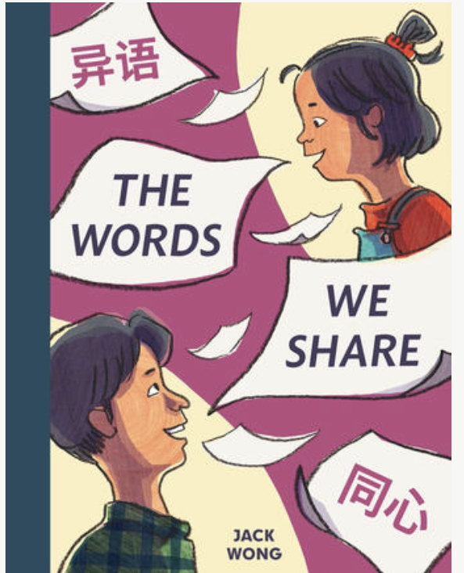

The Words
We Share

Written and Illustrated by Jack Wong

Book Discussion Questions
After Reading

- What did you enjoy about this book?
- Where (what places) does this story take place? (What is the setting of the story?)
- Who is the main character in the story?
- What words would you use to describe the main character?
- How did the illustrations help you to understand the story?
- What happened when Angie and her dad went to the laundromat?
- What did Angie learn about her dad in this story?
- Why do you think the author chose the title: The Words We Share?

