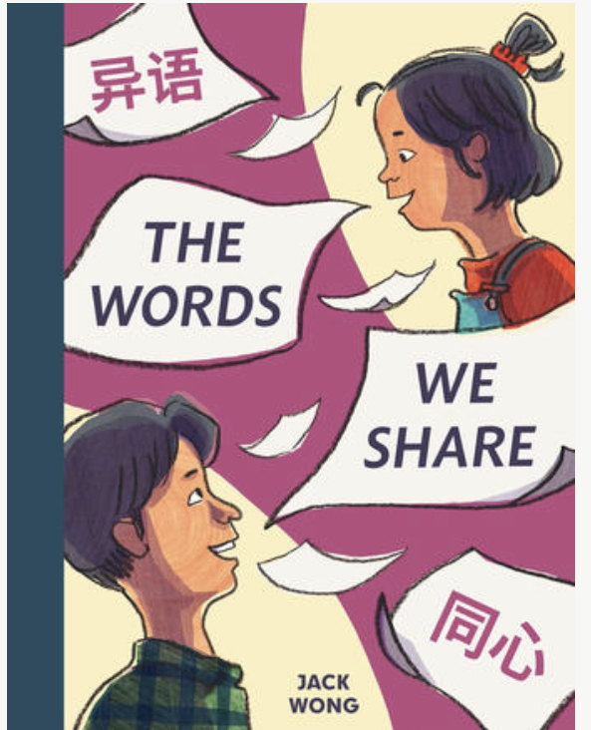

The Words
We Share

Written and Illustrated by Jack Wong

Drawing Conclusions
Discussion Questions

Ask readers to use what they know and the text and illustrations to help draw conclusions. What do they read or see in the book that helps them make each conclusion?

- Does Angie like to help her dad?
- How does Angie feel when Mr. Chu calls to complain about her sign at the laundromat?
- When Angie and her dad are walking home from the laundromat, Angie thinks that her dad looks changed but also not. Has her dad changed? What did Angie learn about her dad?
- At the end of the story, how does Angie feel? Does she want to continue to make signs?
- !.
- 2
- 2

