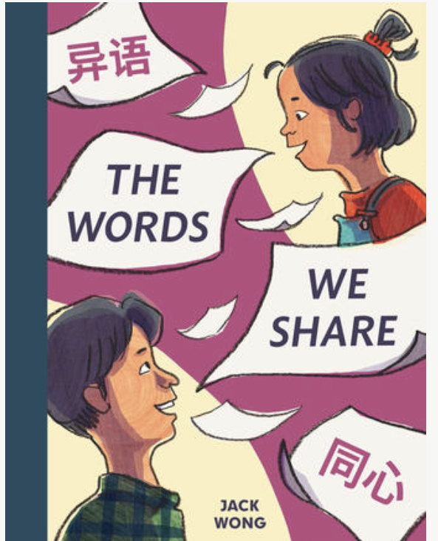
Name: ___________________________
Date: ____________________________

The Words
We Share

Written and Illustrated by Jack Wong
Missing Letter Fun
Figure out the missing letters. Write them in the boxes.
A
n
g
e

Angie
D

Dad
o
d

words

h
r

share

