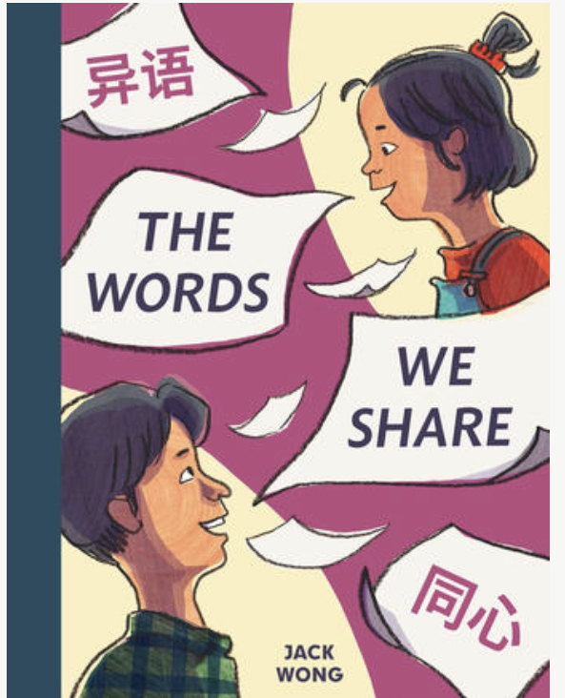
Name: ___________________________
Date: ____________________________

The Words
We Share

Written and Illustrated by Jack Wong

Writing Activity

Be Angie for a day! Create a Welcome sign!
Ms. Fong wants to welcome customers who speak all languages to her canteen. Write the word, Welcome, in English and one another language: any language of your choosing!
You can decorate your sign with your favourite foods.

