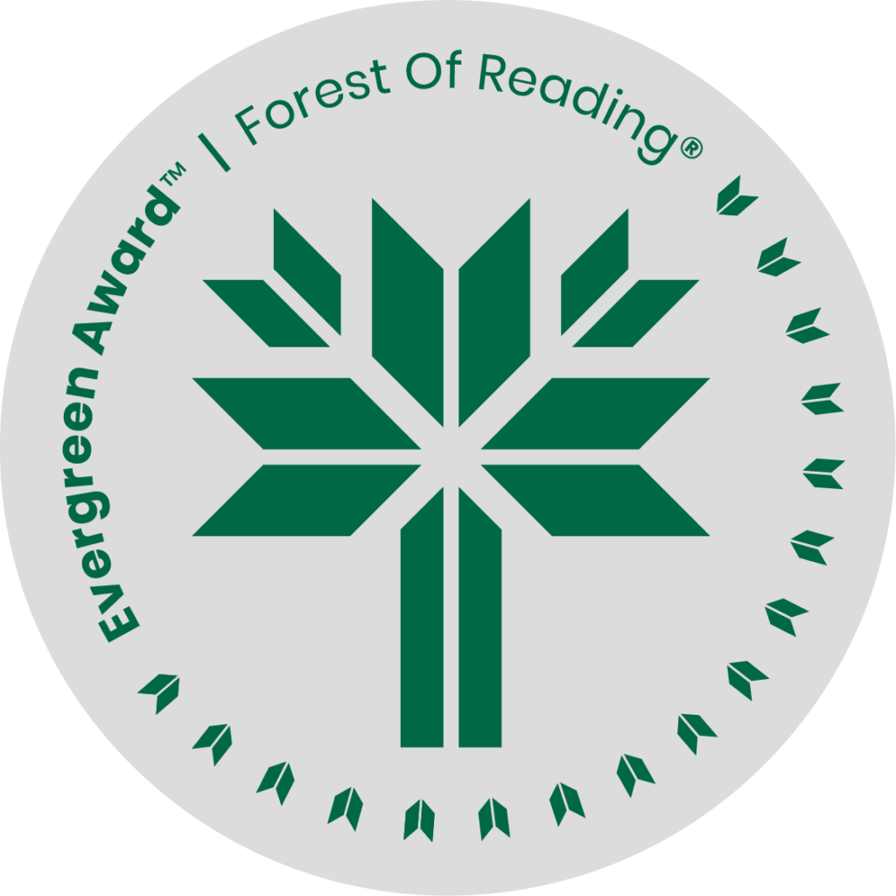

Far Cry by Alyssa York

**DISCUSSION QUESTIONS HERE** (Ideally 10 questions to guide discussion of the title):

1. This novel is set in the real British Columbia town of Rivers Inlet, where there was a cannery in the 1920s, called Good Hope. Why do you think that Alissa York chose to name her fictional cannery Far Cry? What images and emotions do the words “far cry” evoke for you?
2. If you could paint an abstract painting, or create a photo collage to represent the setting of *Far Cry*, what colours and images would you use?
3. Early in the novel, Anders’ mother tells him “Anders, there is only one road in this life.” What do you think about that statement? How does it affect Anders’ life decisions?
4. What role, realistic or symbolic, does the sea play in this novel?
5. What serious problems or issues in our history does this novel address? Which is the most important to the plot of the novel in your opinion?
6. Could this story happen today in Canada? Has there been significant social change in the past hundred years with regard to the serious issues that fuel the plot of the novel?
7. What is positive, inspiring or uplifting in this novel? What makes the characters happy?
8. Is *Far Cry* a love story?
9. *Far Cry* is told from two viewpoints: first, through the written memoir of Anders Viken and second, through the eyes of Kit Starrett. Is the way the story is told important?
10. What topics would you like to discover more about after reading this novel?