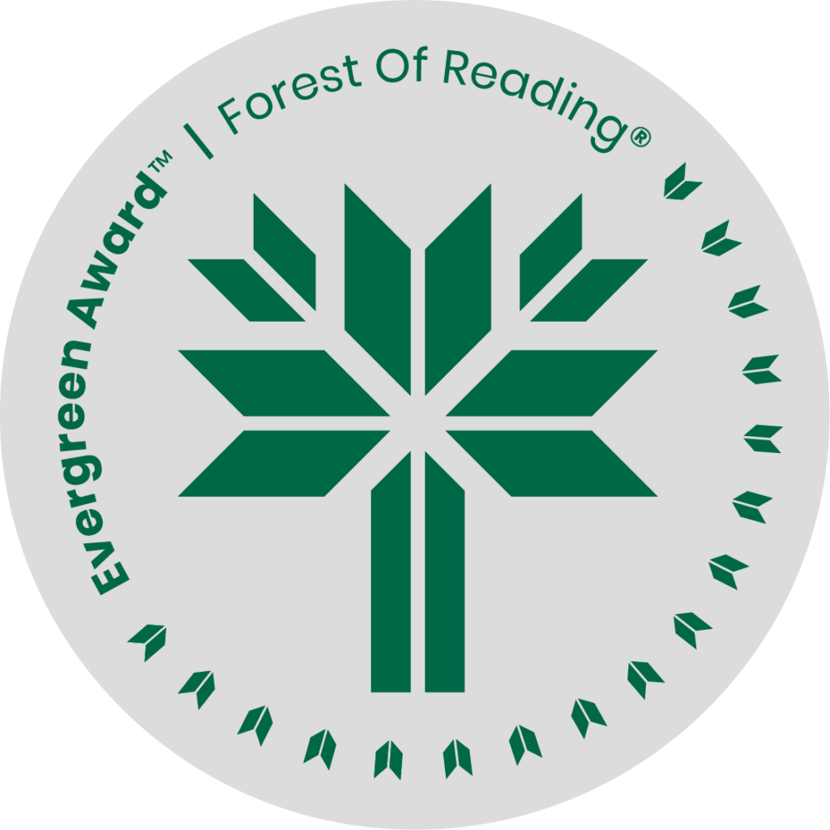

Far Cry by Alyssa York

**SHELF TALKER HERE** (Basic elevator pitch - 30 seconds)**:**

It is just four years since the end of the Great War. Night after night, in an isolated cannery town on the coast of British Columbia, a lonely man with a dark secret scribbles his rambling memoir, pouring out his hidden love and pain to the young woman who has been like a daughter to him. Everyone else he has loved is gone, and now he can only hope for some kind of compassion when his whole story is laid before her. It’s a heart-breaking story that shows how the prejudices of straight-laced morality can twist lives and destroy relationships. Award-winning author Alissa York spins her mystery so deftly that it will keep you guessing until the very last pages of the novel.

If you liked Far Cry you may like:

* Fayne by Ann-Marie MacDonald
* Greenwood by Michael Christie
* Cambium Blue by Maureen Brownlee
* At Last Count by Claire Dunn Ross
* Dandelion by Jamie Chai Yun Liew
* Sweetland by Michael Crummey
* Emancipation Day by Wayne Grady
* All the Colour in the World by C. S. Richardson
* The Wars by Timothy Findley