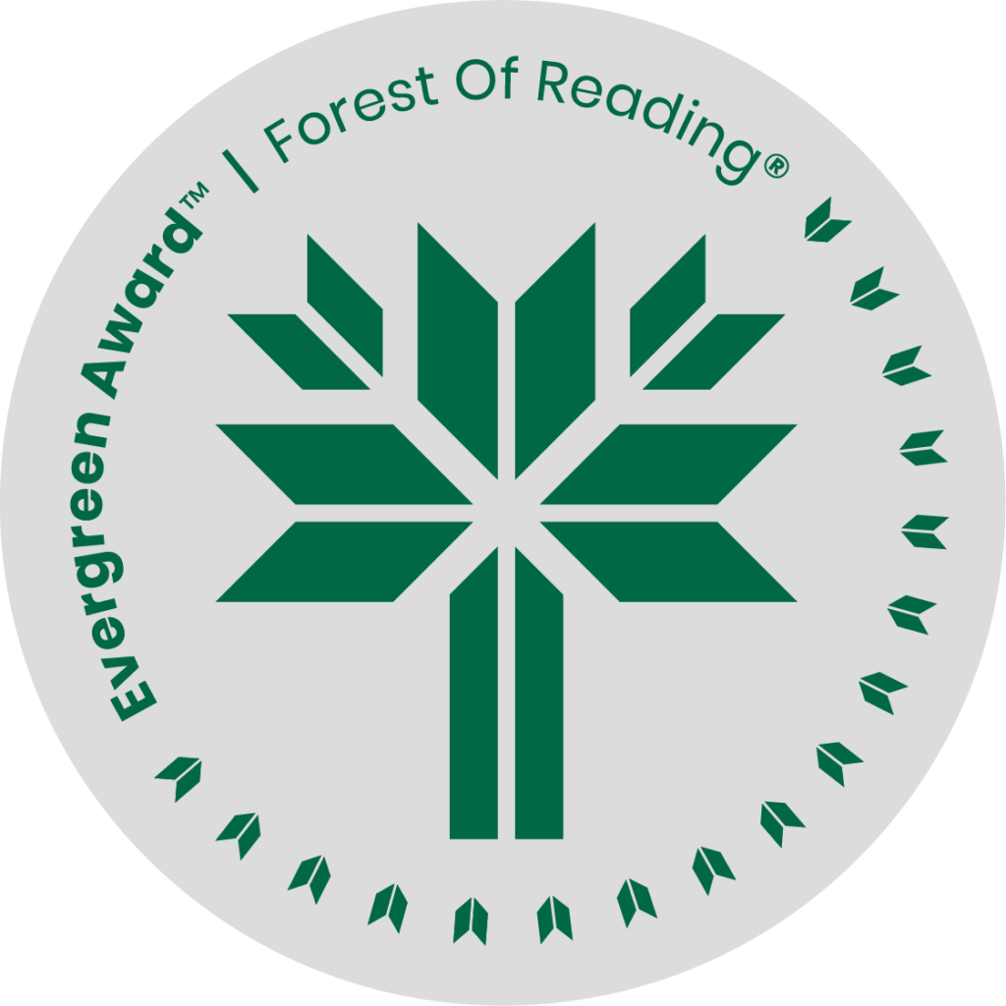

Fire Weather: The Making of a Beast by John Vaillant

**DISCUSSION QUESTIONS HERE** (Ideally 10 questions to guide discussion of the title):

1. Wildfires have been in the news a lot in recent years - was there anything that surprised you about how and why they have become more frequent?
2. What was the main message or lesson of this book? Has it inspired you to take any action or make any changes in your life? What are some specific steps or strategies that you will use?
3. Were you surprised to learn about the multiple scientists who warned governments and oil and gas multinationals of the near-certain climate change humans would cause by continuing to burn fossil fuels, and how they were ignored? Why or why not?
4. What are the three (3) most useful or valuable things you learned from reading this book?
5. There were many personal, true stories from survivors and firefighters who were in Fort McMurray during the 2016 fires. Which of them stood out most to you?
6. One personal story told was about a man who would not leave his home during the evacuation. Why do you think he wouldn’t leave? Would you leave if you were in his situation?
7. Many people struggled with what to pack when the evacuation order finally came - what is one thing you would have packed, and why?
8. The book has been described as a “gripping narrative and a loud wake-up call.” What questions do you still have after reading this book? What would you like to learn more about?
9. The headline on an article in The Tyee reads “When John Vaillant Contemplates Catastrophe, We Should Listen.” Do you feel like anyone is listening? What will you do to make people listen?