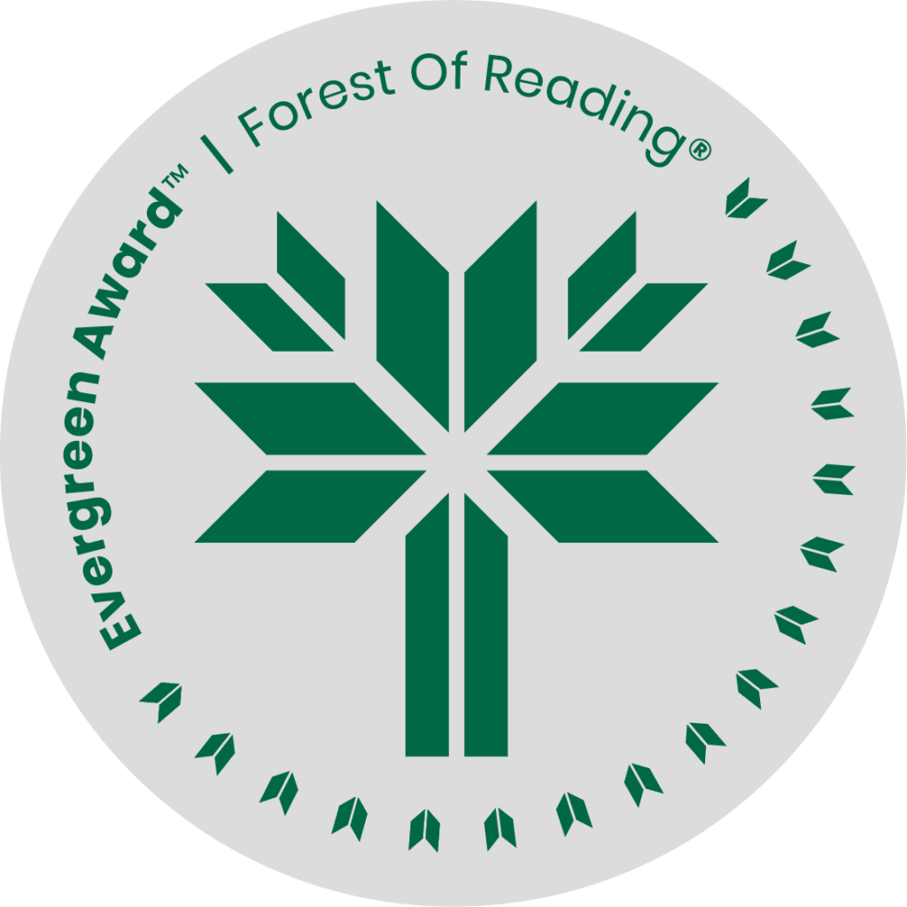

Silver Nitrate by Sylvia Moreno-Garcia

**DISCUSSION QUESTIONS HERE** (Ideally 10 questions to guide discussion of the title):

1. What did you enjoy most about Silver Nitrate? What did you struggle with?

2. Was there a character you wish had a bigger role, or one you wished you could know more about?

3. This book might be considered an extreme take on “movie magic.” Which type of character would you be in a classic horror movie? Would you try to do everything on your own, or recruit a friend?

4. Despite (or perhaps because of) their longtime friendship, Montserrat and Tristán remain very close, although they can be very different from each other. Do you think this can be a good thing? Are they good friends to each other? Explain.

5. The book takes place in 1993, with many elements typical to the ‘90s (VCRs, answering machines, etc.), but the magic is even older. Do you think this story could have worked in a different time? Why or why not?

6. The magic systems in this book are “invented” by the mysterious Wilhelm Ewers. While his version is based on pseudoscience and a mix of cultural practices, how do you feel about Montserrat’s approach to magic? Do you think magic can be practiced by anyone?

7. Movies and magic are major themes in Silver Nitrate. What other themes did you notice?

8. How do you feel about the ending? What do you think happens next with Montserrat and Tristán?

9. Do you think there are any villains in the book? Why or why not? Which character’s motives do you feel most sympathetic toward? The least?

10. What medium do you think would be the easiest to “curse” today—a movie, TV show, podcast, social media, something else? What would your motive be?

Questions, and additional material, available in the official book club kit for Silver Nitrate.

Download for free:

<https://silviamoreno-garcia.com/wp-content/uploads/2023/07/Book-club-kit-Silver-Nitrate.pdf>