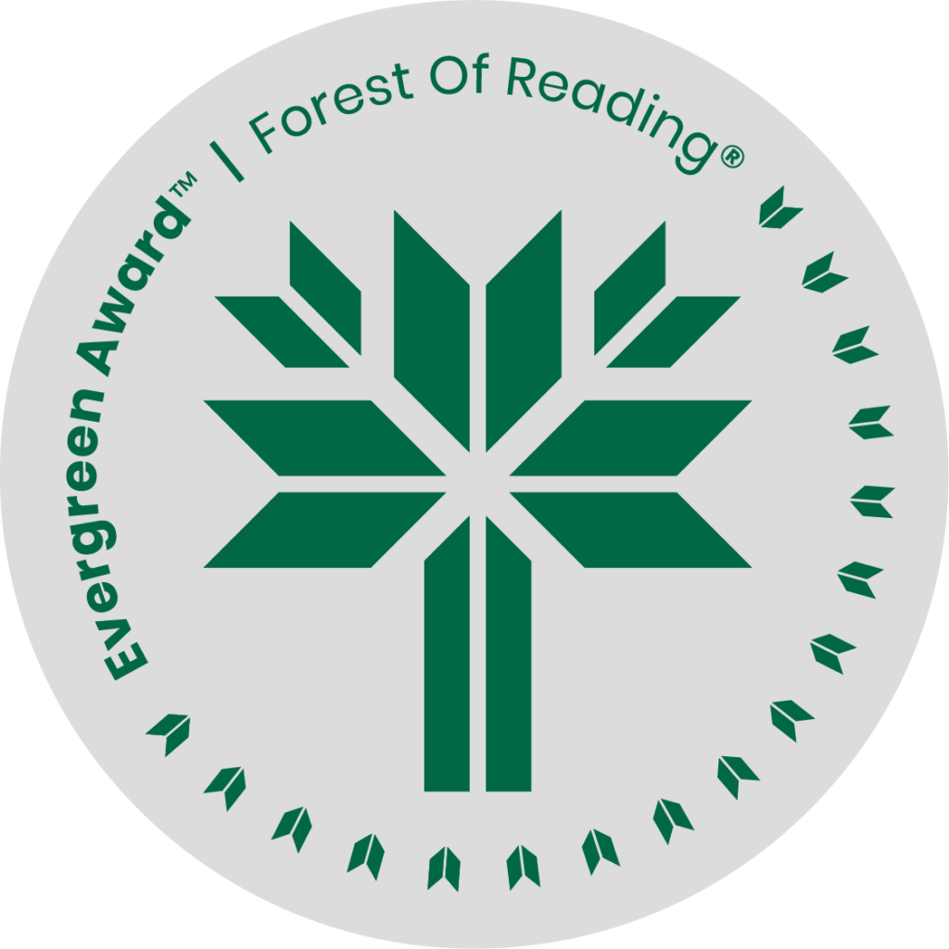

Silver Nitrate by Sylvia Moreno-Garcia

**SHELF TALKER HERE** (Basic elevator pitch - 30 seconds)**:**

Silver Nitrate brings back old-school cool with Chiclets gum, *Fangoria* magazine, and scary flicks! Flawed main characters, a cult, and a cursed film envelop readers like the dark of a theatre. And just like silver nitrate on a wound, this book is a slow burn with a storyline that nicely wraps up all the questions and mysteries taunting us through her story. Garcia’s latest is a tribute to storytelling and cinema.

If you liked Silver Nitrate you may like:

* Bad Cree by Jessica Johns
* Chrysalis by Anuja Varghese
* Places Like These by Lauren Carter
* Buffalo is the New Buffalo by Chelsea Vowel
* Lesser Known Monsters of the 21st Century by Kim Fu