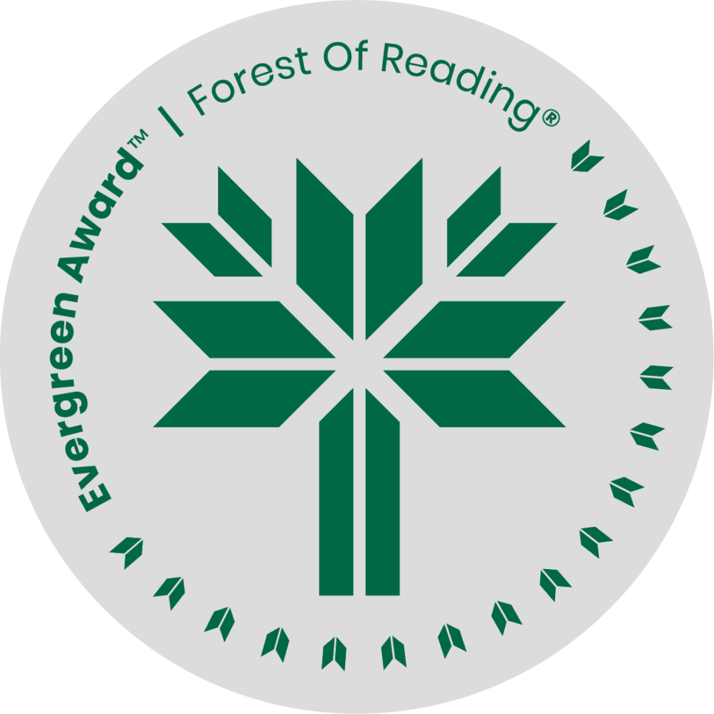

Superfan: How Pop Culture Broke My Heart by Jen Sookfong Lee

**DISCUSSION QUESTIONS HERE** (Ideally 10 questions to guide discussion of the title):

1. In an interview, Jen comments that two questions arose for her: one, why do I care so much about pop culture in general, but two, why do I care so much about pop culture that didn't actually serve me? Has she answered those questions? How?
2. Lee made numerous references to ‘Asian fetish’. Do you think that is exclusive to Asian culture or do you think other cultures are fetishized?
3. Are you influenced by popular culture? In what way? Do you have any current pop culture obsessions? If so, what are they? How and/or why do they speak to you?
4. Each essay connects to a broader theme. What parts of your life w/could you pair up with specific pop culture moments or figures she uses as essay titles?
5. Does reading this book allow you to better interrogate the pop-culture that you consume? What role does pop culture play in your life? How do you relate to it? How does it make you feel?
6. Pick a pop cultural icon you are familiar with. Why do people keep consuming their content? What is it that they're giving us? What is the fascination?
7. What is the significance of the title? Do you think the title accurately reflects her memoir?
8. What was your favourite essay and why?
9. The author has a very complicated relationship with her Mother. Who do you feel has the worst end of their relationship, Jen or her Mother? How do you think the author’s Mother would feel about this book?