Yellow Cedar Activity: Coding Activity

*Haunted Canada: Graphic Novel* by Joel Sutherland

Name: ______________________________

1. Open the game *Haunted Canada* at <https://scratch.mit.edu/projects/1072466173>

2. Click the green flag to start. Move Scratch Cat through the haunted forest using the cursor to the green flag. But watch out for ghosts who might appear from the book!

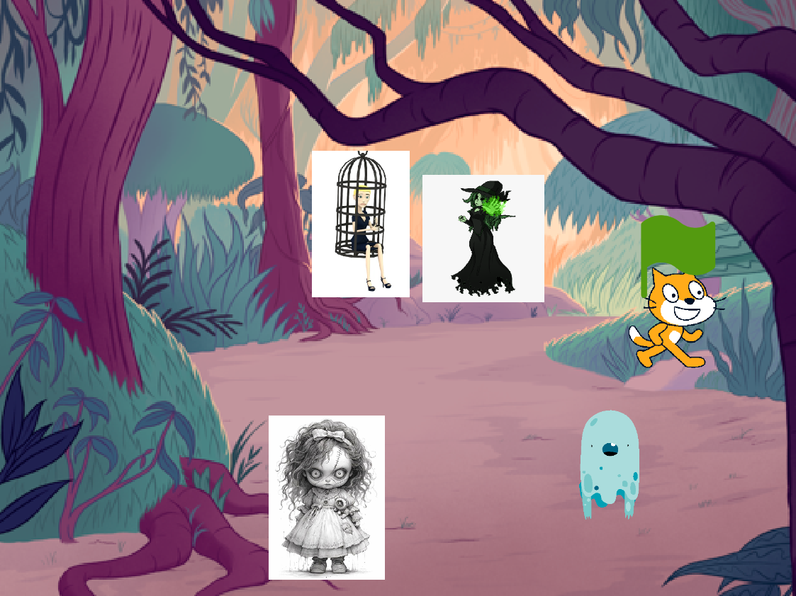

3. Create your own Scratch account by visiting <https://scratch.mit.edu/>. You can remix The Haunted Canada game by adding some ghosts of your own, or make a new game from “scratch.”