Queer History A to Z: 100 Years of LGBTQ+ Activism   
**Word Wise** 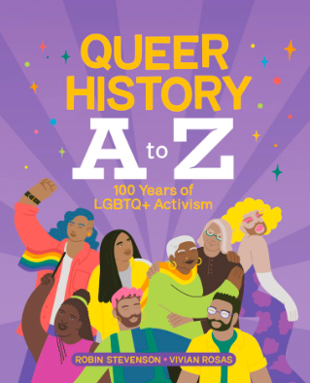

Before you dig into this wonderful history of LGBTQ+ Activism, you may want to check on the definitions of the following words (see page 24 for some help):

| **WORD** | **DEFINITION** | |
| --- | --- | --- |
| QUEER |  | |
| TRANSGENDER |  | |
| GENDER |  | |
| GAY |  | |
| LESBIAN |  | |
| BISEXUAL |  | |
| NON-BINARY |  | |
| SEXUALITY |  | |
| HOMOPHOBIA |  | |
| DRAG |  | |
| PRIDE |  | |
| EQUALITY |  | |
| CENSORSHIP |  | |
| IDENTITY |  | |

Choose one of the above words that you didn’t know or with which you were a little unclear and explain it in your own words: ____________________________________________________________________________________________________________________________________________________________________________________

What is something you still have a question or wondering about? ________________________________________________________________________________________________________________________