Yellow Cedar Activity: Craft Activity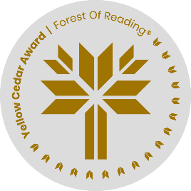

*Haunted Canada: Graphic Novel* by Joel Sutherland

Name: ______________________________

It’s time to make some paper dolls, Mandy-style! Use the attached template to create your own creepy paper doll. Choose from a variety of clothing and heads. You can cut them out and build them on the template, or create your own backdrop (an abandoned house or old museum are good places to find creepy dolls). Then add colour to your doll clothes using paper crayons or markers.

For a bigger challenge, use the internet to search for examples of vintage doll clothes and print them off for Mandy. Or you could draw your own!

