Queer History A to Z: 100 Years of LGBTQ+ Activism   
**Discussion Questions** 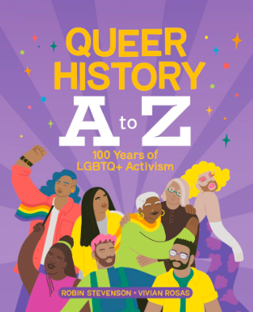

**Before Reading**   
What do you already know about the history of the queer community?   
What do you want to know about the history of queer community?

What are you still curious about with regard to the queer community?

When is the last time you’ve taken a stand about something? What is an issue about which you feel passionate? Is there an issue that is really important to you?

**During Reading**   
What are you wondering about?

What questions do you have so far?

**After Reading**  
Why do you think the author, Robin Stevenson, wrote this book? Why was it an important book to write?

What is the author’s message? What themes did you find throughout the book?

Which “letter” in the book has inspired you to want to learn more about queer history? Why?

Sometimes, books with queer content or characters are challenged in libraries by people who think that they aren’t appropriate, especially in school libraries. Why do you think that is? How does the [Ontario Human Rights Code](https://www.ontario.ca/laws/statute/90h19) and the [Canadian Charter of Rights and Freedoms](https://www.justice.gc.ca/eng/csj-sjc/rfc-dlc/ccrf-ccdl/) help protect authors, illustrators (especially those who are 2SLGBTiA+ identifying), schools, and librarians from book banning and/or book challenges?