See It, Dream It, Do It   
**“Spin Off Jobs”**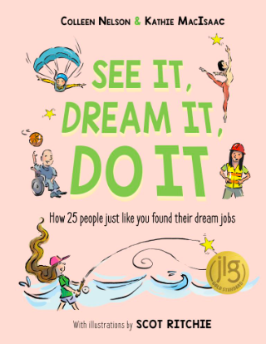

Fifty years ago no one could have predicted that we would have a whole industry based in computer engineering and coding. Thirty years ago the first hybrid cars hit the market and now electric cars are everywhere. Twenty years ago Apple released the first iPod and forever changed the way we listen to music. How will the job force change in the next 20 years? 50 years? 100 years? What will your role be in the job force when you are finished with school? Will you have a job similar to jobs today? Will you create a new role for yourself in the workforce of the future?

| ____________________________________________________________________________________________________________________________________________________________________________________________________________________________________________________________________________________________________________________________________________________________  __________________________________________________________________________________________________________________________________________________________________________________________________________________________________________________________________________________________________  __________________________________________________________________________________________________________________________________________________________________________________________________________________________________________________________________________________________________  ________________________________________________________________________________________________________________________________________________________________________________________________________________________________________ |
| --- |
|