**Little by Little You Can Change the World**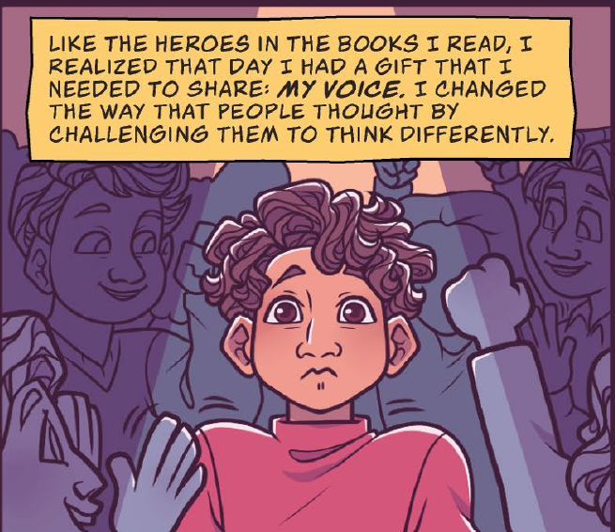

**Name:**

**Date:**

*Using the seven transferable skills, (critical thinking and problem solving; innovation, creativity, and entrepreneurship; self-directed learning; collaboration; communication; global citizenship and sustainability; digital literacy) identify an issue in your school, community, or broader community that needs a solution.*

1. What is the issue you have identified?

2. What actions could be done to help with this issue?

3. How can you be a leader for this issue?

4. How can you help?

***Let's take action!***