Queer History A to Z: 100 Years of LGBTQ+ Activism   
**Dig Deeper** 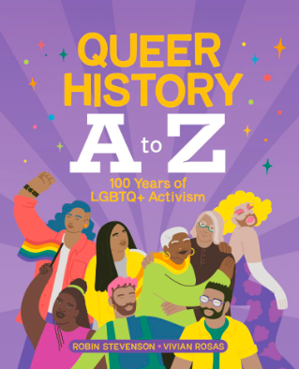

Did you know that the International Day of Pink celebrated the second Wednesday in April is based in a Canadian grassroots movement? Go to [DayofPink.ca](http://dayofpink.ca) and learn more about the history of Day of Pink.   
  
Then choose one of the following milestones from the 2SLGBTQIA+ timeline:

| [The LGBT Purge](https://www.dayofpink.org/lgbt-purge) | [Coining of the phrase “Two-Spirit”](https://www.dayofpink.org/two-spirit) |
| --- | --- |
| [The Brunswick Four](https://www.dayofpink.org/brunswick-four) | [The Trans Flag](https://www.dayofpink.org/trans-flag) |
| [Depathologization of Homosexuality](https://www.dayofpink.org/dsm) | [The Stonewall Riots](https://www.dayofpink.org/stonewalltour) |

Give a brief summary of the event?

____________________________________________________________________________________________________________________________________________________________________________________________________________________________________________________________________________________________________________

Why was it important to the 2SLGBTQAI+ community?

____________________________________________________________________________________________________________________________________________________________________________________________________________________________________________________________________________________________________________

What have you learned? What is your take away?

____________________________________________________________________________________________________________________________________________________________________________________