See It, Dream It, Do It   
**Workplace Playlist** 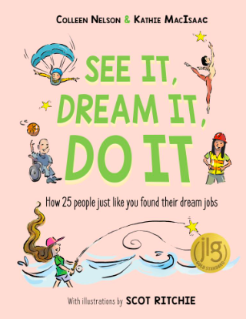

Choose a profession from the list below from “See It, Dream It, Do It.” Now imagine what that workplace environment looks like. Who works there? What kind of setting is it? What do you hear around you?

| LEGO Designer | Midwife | Electrical Engineer |
| --- | --- | --- |
| Funeral Director | Pilot | Private Investigator |
| Cybersecurity Analyst | Paleontologist | Stand Up Comedian |
| Ballet Dancer | Cave Microbiologist | Stand Up Comedian |
| Park Ranger | Travel Company Owner | Fitness Trainer |
| Ranch Owner/Equine Therapist | Architect | Teacher/Basketball Coach |
| Radio Host/Multimedia Journalist | Forensic Artist | Heavy Equipment Technician |

Now, imagine the perfect playlist for that workplace. What songs would make your day at that job even more fun and enjoyable?

**Playlist**

| **Song Title** | **Artist** |
| --- | --- |
| **1.** |  |
| **2.** |  |
| **3.** |  |
| **4.** |  |
| **5.** |  |
| **6.** |  |
| **7.** |  |
| **8.** |  |
| **9.** |  |
| **10.** |  |