Yellow Cedar Activity: Word Search (Answers)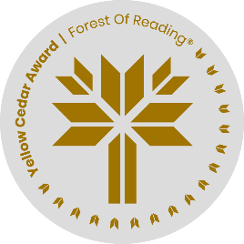

*Haunted Canada: Graphic Novel* by Joel Sutherland

Name: ______________________________

1. Find the words below in the word search.

| P | I | S | L | A | N | D | H | F | O | R | E | S | T |
| --- | --- | --- | --- | --- | --- | --- | --- | --- | --- | --- | --- | --- | --- |
| D | O | L | L | H | A | C | A | G | E | C | L | H | M |
| M | U | R | D | E | R | U | U | N | B | U | A | I | U |
| A | A | G | C | R | Y | I | N | G | O | R | M | P | S |
| R | T | N | H | E | E | D | T | D | N | S | B | W | E |
| O | C | A | D | O | L | N | E | P | E | E | A | R | U |
| O | D | A | G | Y | S | A | D | M | O | R | A | E | M |
| N | S | P | I | R | I | T | I | P | O | L | H | C | I |
| M | I | D | N | I | G | H | T | N | C | N | I | K | N |
| O | V | N | E | I | G | H | B | O | U | R | E | O | L |

BONE DOLL LAMB NEIGHBOUR

CAGE FOREST MAROON POLIO

CRYING GHOST MIDNIGHT PORCELAIN

CURSE HAUNTED MURDER SHIPWRECK

DEMON ISLAND MUSEUM SPIRIT

2. Copy the unused letters to determine the secret phrase. (HINT: the letters are in order.)

__ __ __ __ __ __ __ __ __ __ __ __ __ : __ __ __ __ __ __ __ __ __ __ __ __