Queer History A to Z: 100 Years of LGBTQ+ Activism   
**Activist Playlist** 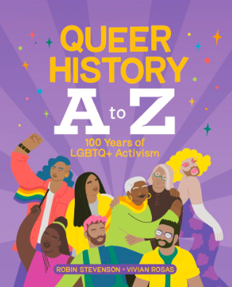

Choose one of the activists from the list below from “Queer History A to Z: 100 Years of LGBTQ+ Activism.” Now put yourself in their shoes. What do you hear around you? What music do you think might be playing? Create the perfect playlist to help tell the story of this icon.

| Bayard Rustin | Ernestine Eckstein | Jazz Jennings |
| --- | --- | --- |
| Marsha P. Johnson | Urvashi Vaid | Amiee Stephens |
| The Brunswick Four | Barbara May Cameron | Barbara Gittings |
| Makeda Silvera | Harvey Milk | James Baldwin |
| Gladys Bentley | Helen Zia | Jim Egan |
| Ken Jones | Michelle Douglas | Li Shiu Tong |

**Playlist**

| **Song Title** | **Artist** |
| --- | --- |
| **1.** |  |
| **2.** |  |
| **3.** |  |
| **4.** |  |
| **5.** |  |
| **6.** |  |
| **7.** |  |
| **8.** |  |
| **9.** |  |
| **10.** |  |
| **11.** |  |
| **12.** |  |