See It, Dream It, Do It   
**Word Search**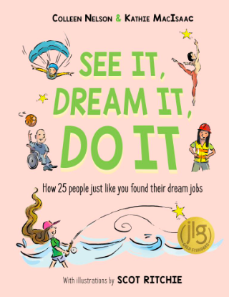

Find the words below hidden among the letters. Words can be horizontal, vertical, or diagonal.   
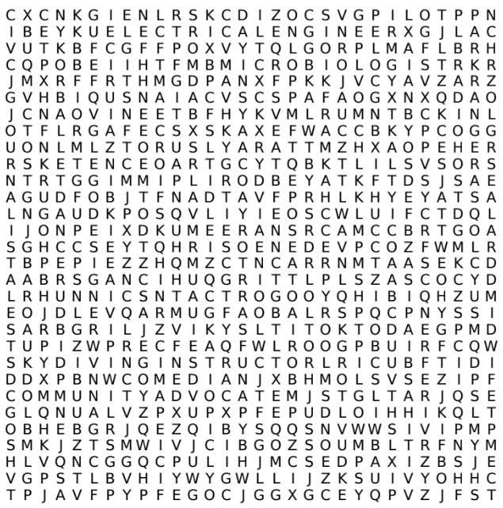

| Ambassador | Architect | Ballet Dancer |
| --- | --- | --- |
| Basketball Coach | Charter Captain | Comedian |
| Community Advocate | Cybersecurity Analyst | Electrical Engineer |
| Fitness Trainer | Forensic Artist | Funeral Director |
| Journalist | LEGO Designer | Microbiologist |
| Midwife | Paleontologist | Park Ranger |
| Pilot | Radio Host | Skydiving Instructor |