See It, Dream It, Do It   
**Dream Job** 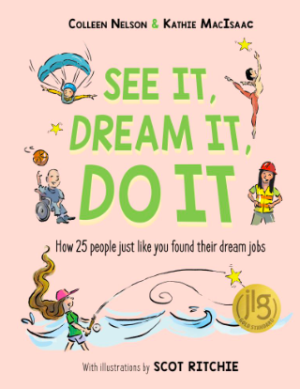

If you could imagine any job in the world for yourself - what would it be? In the space below, draw, doodle, brainstorm, write, or imagine what your dream job might look like. Sunset/sunrise designer? Paint colour naming guru? Locker interior decorator? S’mores taste tester?

If you want to do it - first you have to see it and dream it! Have fun!