Queer History A to Z: 100 Years of LGBTQ+ Activism   
**Word Search Answer Key**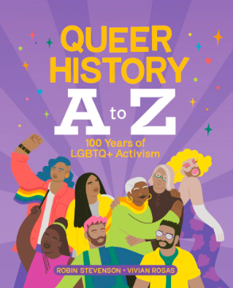

Find the words below hidden among the letters. Words can be horizontal, vertical, or diagonal.

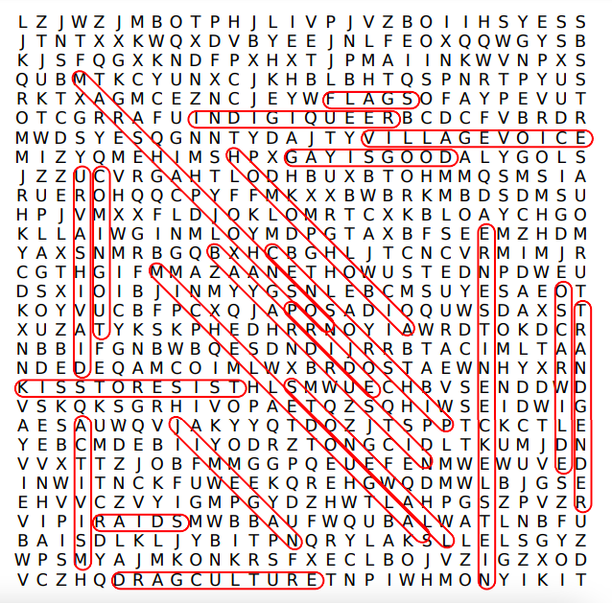

| ACTIVISM | BAYARD RUSTIN | CENSORSHIP |
| --- | --- | --- |
| COMING OUT | DRAG CULTURE | ERNESTINE ECKELSTEIN |
| FLAGS | GAY IS GOOD | HOMOPHOBIA |
| INDIGIQUEER | JIM EGAN | KISS TO RESIST |
| MARSHA P JOHNSON | MICHELLE DOUGLAS | OSCAR WILDE |
| PRIDE | RAIDS | STONEWALL |
| TRANSGENDER | URVASHI VAID | VILLAGE VOICE |