Queer History A to Z: 100 Years of LGBTQ+ Activism   
**Additional Resources** 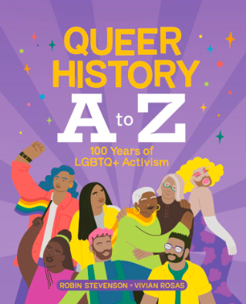

**Author’s Website**

[robinstevenson.com](http://robinstevenson.com)

Robin Stevenson is the award winning author of more than thirty books of fiction and nonfiction for kids and teens. Her books have won the Silver Birch Award, the Sheila A. Egoff award and a Stonewall Honor, and been finalists for the Governor General’s Literary Awards, the Lambda Literary Awards, and many reader’s choice awards.

**Heritage Moment - Jim Egan**

[Historica Canada - Jim Egan](https://www.historicacanada.ca/productions/minutes/jim-egan)

Jim Egan (1921-2000) was one of Canada’s first gay activists. He met his life partner after serving in WWII. In 1988, he applied for his partner, Jack, to receive spousal benefits through Canada’s Old Age Security program and was denied. Despite living with Jack for over 40 years, their same-sex relationship did not consider him a common-law spouse. Watch the video to see what happened when they challenged the law all the way to the Supreme Court.

**CBC News Kids - The History of Pride**

[The History of LGBTQ Pride: From Stonewall to Corporate Branding](https://www.cbc.ca/kidsnews/post/watch-the-history-of-the-pride-movement-and-its-importance-today)

While today you may think of Pride as a month of celebration, it started with protest movements and calls for equal rights for gay and lesbian people. How has the Pride movement changed throughout the years? Why is it still important today? And how does the LGBTQ community feel about brands using Pride Month to promote themselves?

Watch this video from CBC News kids for a short video to learn more.