See It, Dream It, Do It   
**Jobs Between the Pages** 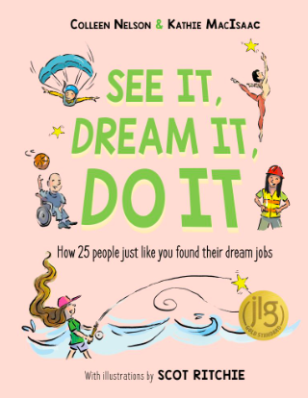

Have you ever been inspired by any of the Forest of Reading titles you’ve read? Can you think back to any of the characters in those books and the jobs that they had?

For example:

The Umbrella House → graffiti artist

Apartment 713 → building manager

Berani → animal activist

The Big Sting → bee keeper

Simon Sort of Says → funeral director

Batter Royale → professional chef

Swept Away → detective

The Case of the Rigged Race → dogsled racer

Peter Lee’s Notes from the Field → palaeontologist

Bear in the Family → veterinarian

The Strangest Thing in the Sea → deep water diver

Flipping Forward & Twisting Backward → gymnast / coach

Raymond the Buffalo → Librarian

What book has a character with a job that inspires you?

Title of Book: _______________________________________________________________

Name of character: _________________________________________________________

Job: ________________________________________________________________________

Why does it inspire you?

____________________________________________________________________________________________________________________________________________________________________________________________________________________________________________________________________________________________________________