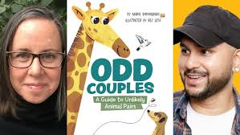

**Odd Couples:**

**A Guide to Unlikely**

**Animal Pairs**

Maria Birmingham

Illustrated by Raz Latif

Learning About Hummingbirds

There are many types of hummingbirds. Research different species and record your findings in the chart. Try to find hummingbirds that are found in Canada.

| **Hummingbird Species** | **Habitat** | **Food** | **Life Cycle** | **Predators** | **Photo &**  **Features** |
| --- | --- | --- | --- | --- | --- |
| Bee Hummingbird |  |  |  |  |  |
|  |  |  |  |  |  |
|  |  |  |  |  |  |
|  |  |  |  |  |  |

Website Suggestions:

[Hummingbirds Canada](https://hummingbirdscanada.ca/hummingbirds/ruby_throated) [Hummingbird Central](https://www.hummingbirdcentral.com/hummingbird-species.htm)