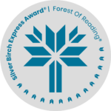
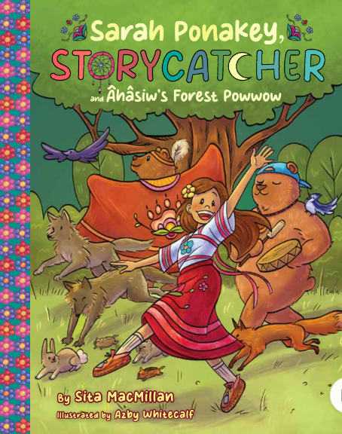
Sarah Ponakey, STORYCATCHER
And Âhâsiw’s Forest Powwow
Sita MacMillan
Illustrated by Azby Whitecalf

Learning Languages
Many Indigenous languages are endangered and at risk of being endangered. Elders and community members are working hard to revitalize languages and record them so that they aren’t lost. Use the chart to learn the words from the story and find 2 other languages to add.
Cree Words | Pronunciation | English Meaning | Language 1 | Language 2
Kôhkom
Maskwa
Tansi’
Âhâsiw
Nêhiyaw
Mêstacâkan
Anikwacās
Maskwachis
Sikak
Mistahimaskwa
Amisk
Kâkwa
Wâposos
Suggestions:
Find another Indigenous language from the Traditional or treaty lands you are on. Add a word from another language your family speaks.
You can also visit https://www.firstvoices.com/home to hear the pronunciation of the Cree language.

