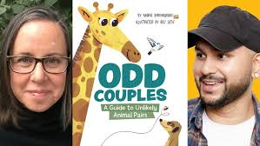

**Odd Couples:**

**A Guide to Unlikely**

**Animal Pairs**

Maria Birmingham

Illustrated by Raz Latif

Comparing Animals

Use the charts below to compare commonly mistaken pairs.

| How can you tell them apart? | Crocodiles | Alligators |
| --- | --- | --- |
| Similarities |  |  |
| Differences |  |  |
| Species Names |  |  |

| How can you tell them apart? | Frogs | Toads |
| --- | --- | --- |
| Similarities |  |  |
| Differences |  |  |
| Species Names |  |  |

**Your turn!**

Pick another pair of animals that are hard to distinguish. Add a picture for each and compare their characteristics.

| How can you tell them apart? | Animal: ___________ | Animal: __________ |
| --- | --- | --- |
| Similarities |  |  |
| Differences |  |  |
| Species Names |  |  |