
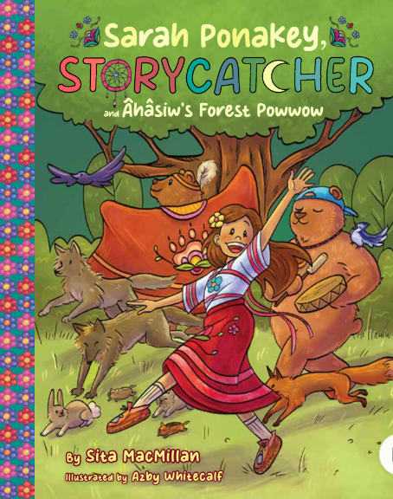
Sarah Ponakey, STORYCATCHER
And Âhâsiw’s Forest Powwow
Sita MacMillan
Illustrated by Azby Whitecalf

Learning About Feelings
In the story, Sarah has a lot of feelings. She has feelings about school and friendships. She also has feelings about dancing for the first time at a powwow with the animals.

What are some of the feelings that Sarah has throughout the story?

How does she cope with those feelings?

Consider a time when you had similar feelings to Sarah? Share your story. How did you cope with your feelings?

List 5 ways to help yourself work through feelings. These can be difficult feelings or positive feelings (e.g., talk to a friend).

1.

2.

3.

4.

5.

