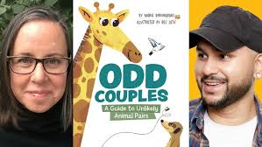

**Odd Couples:**

**A Guide to Unlikely**

**Animal Pairs**

Maria Birmingham

Illustrated by Raz Latif

Matching Odd Couples

Draw lines to match the odd couple animals according to the book.

1. Bee hummingbird Seahorse
2. Koala Snail
3. Wombat Giraffe
4. Opossum Ussurian tube-nosed bat
5. Polar bear White-tailed deer

1. Three toed sloth Human
2. Great white shark Kangaroo
3. Peacock Millipede
4. Meerkat Honeybee