

**Sarah Ponakey, STORYCATCHER**

**And Âhâsiw’s Forest Powwow**

Sita MacMillan

Illustrated by Azby Whitecalf

Learning About Powwows

Use books and internet resources to learn about Powwows.

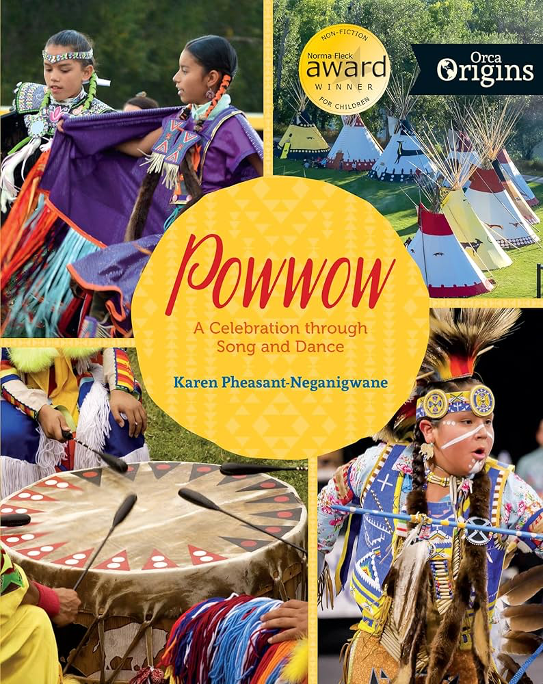 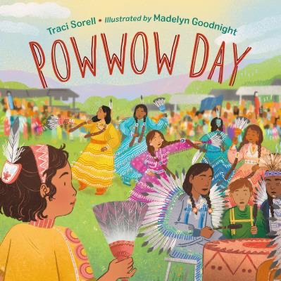

| What do you KNOW? | What do you WONDER? | What did you LEARN from your research? |
| --- | --- | --- |
|  |  |  |

Some questions for consideration:

When do they happen?

Where do they take place?

Who is welcome at a Powwow?

Are Powwows similar to other special events in other cultures? Yours?